Melanie Millet
September 22, 1960 – October 16, 2024

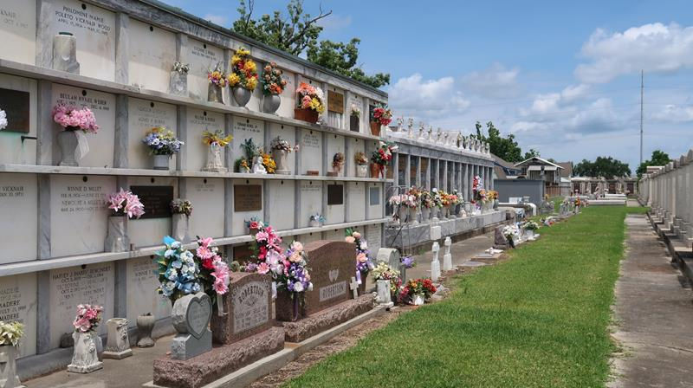

Melanie “MeMe” Millet of LaPlace, LA passed away on Oct 16,2024 at the age of 64.
She is survived by her lifelong companion Nelson Vicknair. Melanie was the daughter of the late Norman S. Millet, Sr. and late Verna Weber Millet. Melanie was the beloved sister of Norman S. Millet, Jr. (Carol), Brenda Millet, Brad Millet (Debbie), Jan Millet, and the late Rosalind Hutson (Jerry).
Melanie was the mother of Brittany Whitehead (Frank) and Brandon Whitehead. She also was a mother figure to many more. Melanie had 4 grandchildren, Mariah Williamson, Frank Williamson III, Kenzie Whitehead, and Kamie Whitehead. She is also survived by a host of nieces and nephews.
During her wonderful life she enjoyed cooking and taking care of others along with being a very hard worker. She will be missed dearly by many.
Family and friends are invited to attend the Funeral Service at St. Joan of Arc Catholic Church, 529 W. 5th Street, LaPlace, LA., on Wednesday, October 23, 2024. Visitation will be held from 10:00 a.m. until time of Mass at 12:00 noon. Interment in St. Peter Cemetery.
Millet-Guidry Funeral Home, LaPlace, Louisiana

