Minnie (Bourgeois) Millet
March 22, 1921 – July 31, 2002

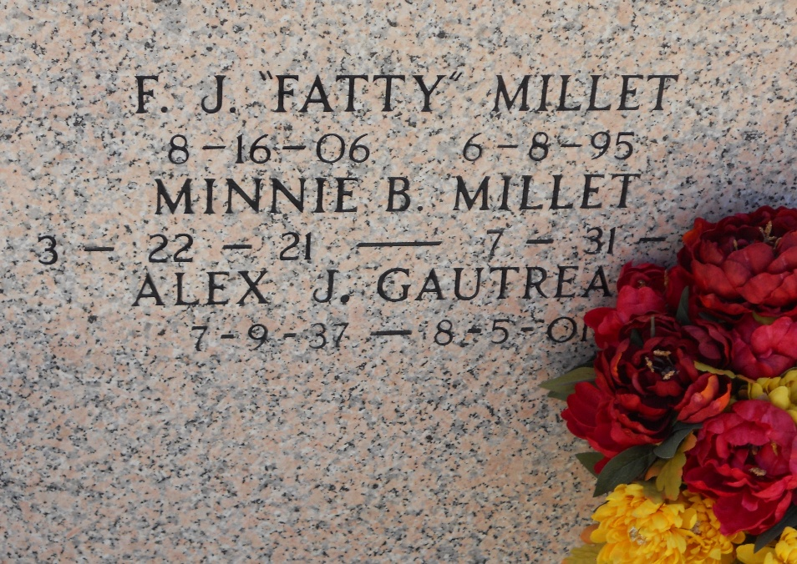
Photo by Team T Lo

Minnie Bourgeois Millet On Wednesday July 31, 2002 At 8:15 P.M.
Beloved Wife Of The Late Ferducie 'Fatty' Millet, And The Late Auley 'Bill' Roussel. Mother Of Amelia R. Daigle Gautreau, Ferrell Millet And Danny Roussel. Sister Of Ervin 'Buddy' Bourgeois. Survived By 10 Grandchildren And 15 Great Grandchildren.
Preceded In Death By Her Parents Humphrey And Kate Allen Bourgeois And Her Sisters Sienna B. Millet And Doris Bourgeois.
Age 81 Years, A Native Of Lutcher And A Resident Of Garyville For The Past 60 Years.
Times Picayune, New Orleans, Louisiana
August 2, 2002

