Noelie (Dufresne) Millet
December 25, 1874 – November 27, 1947

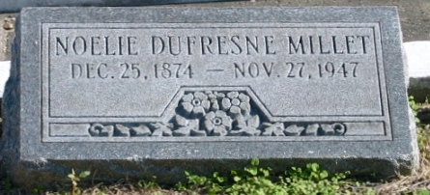
Photo by Bobby

MILLET - at Laplace, La, on Thursday, November 27, 1947, at 10:55 o'clock p.m., NOELIE DUFRESNE, beloved wife of Noe Millet, mother of Mrs. Denise Perilloux Jr, Mrs. Mae Tregre, Mrs. Lillian Noble, Mrs. Annabell Stein, Antoinette and Ernest Millet; also survived by 16 grandchildren, age 73 years.
Relatives and friends of the family are invited to attend the funeral, which will take place on Saturday morning, November 29, 1947, from the Millet Funeral Home, Reserve, La, at 10 o'clock, followed by religious services at St Peter's church, Reserve, La. Interment in St Peter's cemetery, Reserve, La.

The Times-Picayune, New Orleans, Louisiana
29 Nov 1947, p. 2

