Norman Samuel Millet
March 10, 1923 – January 10, 2000

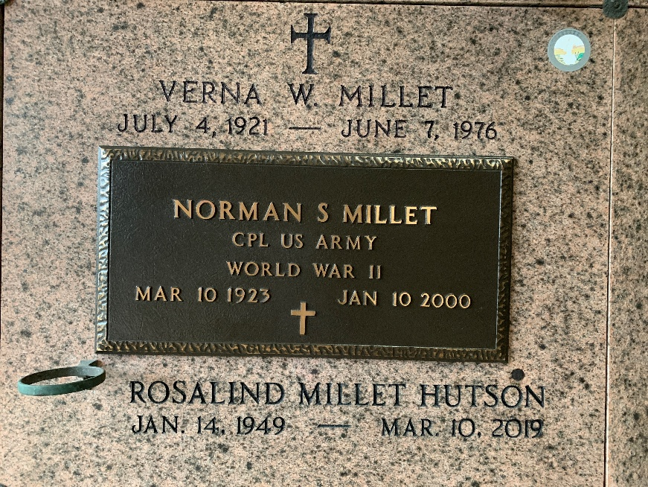
Photo by Team T Lo

Norman S. Millet, 76, a native of Lions and resident of Reserve for 50 years, died Jan. 10. He was the husband of the late Verna Weber Millet, father of Jan Chiquet, Melanie, Brenda, Rosalind, Norman Jr. and Brad Millet and step-father of Lynn, Randy, Kevin and Brent Gordon.
He was also the son of the late Samuel and Corinne Millet and brother of Edna Miano, Velma Jacob, Lucille Barthel and Dennis, Irving, Earl "Mac," Jr., Elson and the late Raymond Millet. He is also survived by 13 grandchildren, nine great-grandchildren and one step-grandchild.
Services are Jan. 13 at 11 a.m. at St. Peter Catholic Church, Reserve, with interment at the church cemetery. Visitation will be held 5-10 p.m. today and starting at 8 a.m. tomorrow.
L'Observateur, LaPlace, Louisiana
January 12, 2000

