Olympe Marie (Perilloux) Millet
December 17, 1868 – July 19, 1959

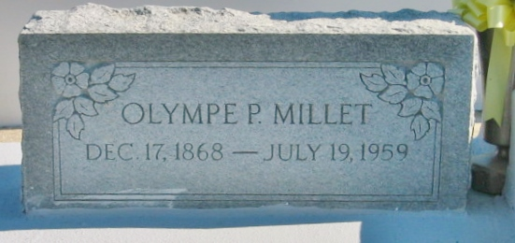
Photo by Bobby

Olympe Perilloux, a native and resident of Laplace, Louisiana, died Sunday, 19 Jul 1959 at 11:45 a.m. at age 90 years.

She was the wife of the late Alberic Millet, and mother of Mrs. Emile Clement, Mrs. Joel Boudreaux, Joseph E. Millet and the late Mrs. Robert Faucheaux. Also survived by 11 grandchildren and 26 great-grandchildren.

Services were Tuesday 21 Jul 1959 at St Joan of Arc Church, Laplace, with interment in St Peter Cemetery, Reserve, Louisiana.
The Times-Picayune, New Orleans, Louisiana
20 Jul 1959

