Winnie (Dufresne) Millet
February 16, 1906 – June 23, 1956

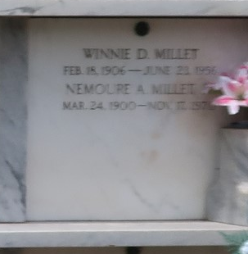

MILLET - At her residence, Montz, La, on Saturday, June 23, 1956, at 9:15 o'clock p.m., WINNIE DUFRESNE, beloved wife of Nemour (Sport) Millet; mother of Mrs. Patrick Hulin of Baton Rouge, La, Mrs. Leon Heurtin Jr and Richard, Elaine and Margaret Millet of Montz, La, Alvin Millet of Norco, La, and Nemour Millet Jr of Laplace, La; daughter of Albert Dufresne and the late Louise Cambre; also survived by seven grandchildren; aged 50 years; a native of Laplace, La, and a resident of Montz, La, for the past 35 years.

Relatives and friends of the family, also employes of the Shell Oil Company of Norco, La, and the National Gypsum Company of Good Hope, La, are invited to attend the funeral, which will take place from Millet funeral home, Reserve, La, on Monday, June 25, 1956, at 8:30 o'clock a.m., followed by mass at St Joan of Arc church, Laplace, La, at 9 o'clock a.m. Interment in St Peter cemetery, Reserve, La.
The Times-Picayune, New Orleans, Louisiana
June 25, 1956, p. 2

