Joseph Robert “Jap” Mills
March 11, 1942 – February 9, 2021

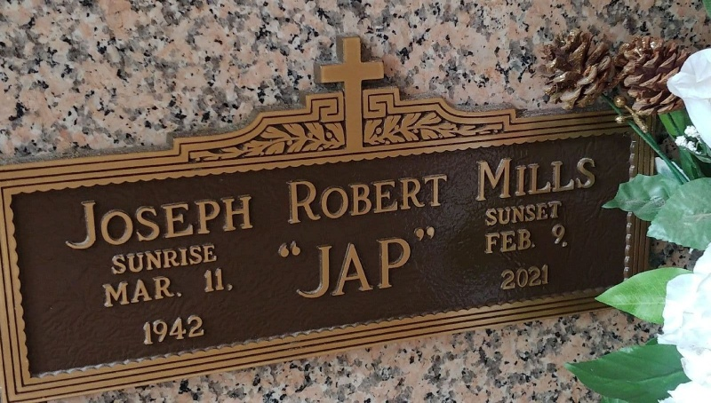
Photo by Team T-Lo

Joseph Robert (Jap) Mills was born March 11, 1942 in New Orleans, LA. He departed this earthly life at Ochsner Hospital in Jefferson, LA on February 9, 2021. He was the son of Sedonia Hall Mills and Alex Mills, Sr.
He was married for 53 years to his devoted and lovely wife Carol Burfict Mills. They were blessed with two sons, Theran and Damian Mills.
Joseph accepted Jesus Christ as his Lord and Savior and was baptized by the late Rev. Ernest Taylor, Sr. He was a disciple of The Greater New Plymouth Rock B.C. under the leadership of Senior Pastor David B. Carter.
He was educated in St John the Baptist Parish Public School System and graduated from Fifth Ward High School Class of 1961. He attended Southern University on a four-year Athletic Scholarship.
Jap was a pitcher for Garyville Giants baseball team and recognized as an All-state player by the National Baseball Congress of America. His prodigious athletic ability to clout home runs and striking out his batters earned him a spot with the Saint Louis Cardinal Minor League Team, Class A. He signed with them on September 28, 1962. Jap’s athletic abilities and passion for the game, from his time at Fifth Ward High School, Southern University and with the Garyville Giants, attracted the Cardinal’s to seek him out. His talent and love for the game extended beyond his playing career in coaching, mentoring and development of local players in and around the community.
Jap leaves to cherish his precious memories his wife, Carol Burfict Mills; two sons, Theran (Nicole) Mills and Damian (Beverly) Mills; grandchildren, Brittany, Michael, Adonijah, Michala, Cierra and Chancellor Mills, as well as a host of in-laws, nieces, nephews, cousins and friends.
Joseph is preceded in death by his father, Alex Mills, Sr.; mother, Sedonia Hall Mills; sister, Aldonia M. Diagre; brother Alex Mills, Jr., and brothers and sisters-in-law, Sophie Mae Burfict, Fabiola Mills, and Johnny Daigre Sr.
There will be a public walk-through visitation held on Wednesday, February 17, 2021 at Treasures of Life Funeral Services, 315 E Airline Hwy, Gramercy, LA 7005 from 10am-11am. Service will begin at 11am. Entombment to follow at St. Peter Catholic Church Cemetery.

Treasures of Life Funeral Services, Gramercy, Louisiana

