Jacqueline (Tregre) Mire
May 21, 1937 – October 29, 2023

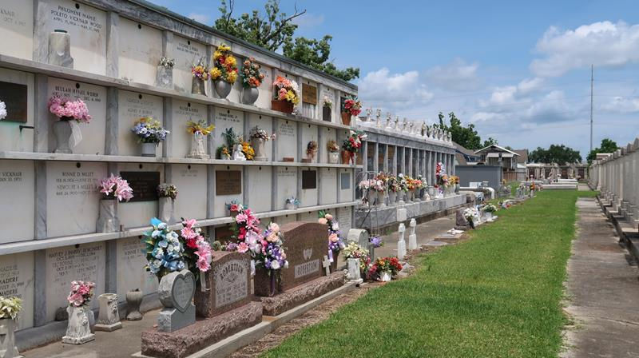

Born May 21st, 1937, Grandma went to be with her Lord and Savior Jesus Christ on October 29th, 2023. She was 86 years old.
Loving Mother of David (Sue Ellen) Mire Sr, Vicki (Lenny) Pousson, and Connie (late Jacob) Leblanc. Also survived by eleven grandchildren, Jennifer, David Jr. Amy, Jamie, Justice Javelin, Journey, Jubilee, Tiffany, Lyndon Jr and Evin.
Wife of the late Henry P. Mire and mother of the late Kevin Mire, and Paul M. Mire. Daughter of the late Vincent J Tregre and Virginia D. Tregre. Sister of the late Nathalie Vicknair, Bobby Tregre, Beverly Tregre, and Vincent Tregre Jr.
A Lifelong resident of Reserve LA, member of AARP, St. Peter’s Ladies Altar Society, St. Peter’s Thrift Shop, St John Council on Aging and Senior Friends of River Parish Hospital. Family and friends who knew her sweet spirit will continue to be inspired by her love.
Relatives and friends of the family are invited to attend a Visitation and Funeral Service in the chapel of Millet-Guidry Funeral Home, 2806 W. Airline Hwy, LaPlace, LA 70068 on Friday, November 3, 2023 from 10:00 a.m. until the Funeral Service at 12:00 p.m. Interment to follow in St. Peter Cemetery, Reserve.

Millet -Guidry Funeral Home, LaPlace, Louisiana

