Kevin P. Mire
March 9, 1959 – January 2, 2010

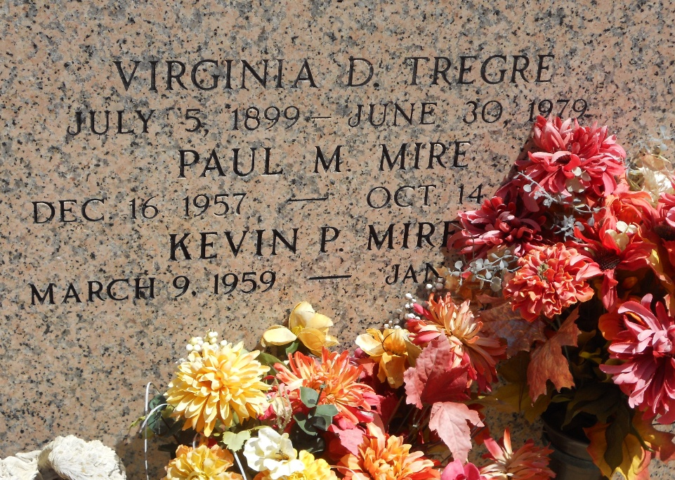
Photo by Team T-Lo

Kevin P. Mire died of pancreatic cancer on Saturday, January 2, 2010 at LSU University Hospital.
Beloved son of Jacqueline Tregre Mire and the late Henry P. Mire. Brother of Vicki M. Pousson, Connie M. LaBlanc, David Mire and the late Paul Mire (all of Reserve). Also survived by numerous nieces and nephews.
Age 50 years. A native and resident of Reserve, La.
Relatives and friends are invited to attend services. Visitation at Millet-Guidry Funeral Home, 2806 W. Airline Hwy., LaPlace, La., on Thursday, January 7, 2010 from 9:00 AM until 11:00 AM. Followed by a Mass of Christian Burial at the Funeral Home Chapel at 11:00 AM. Burial in St. Peter Cemetery, Reserve, La.

The Times-Picayune, New Orleans, Louisiana
Jan. 6, 2010

