Paul Michael Mire
December 16, 1957 – October 14, 2004

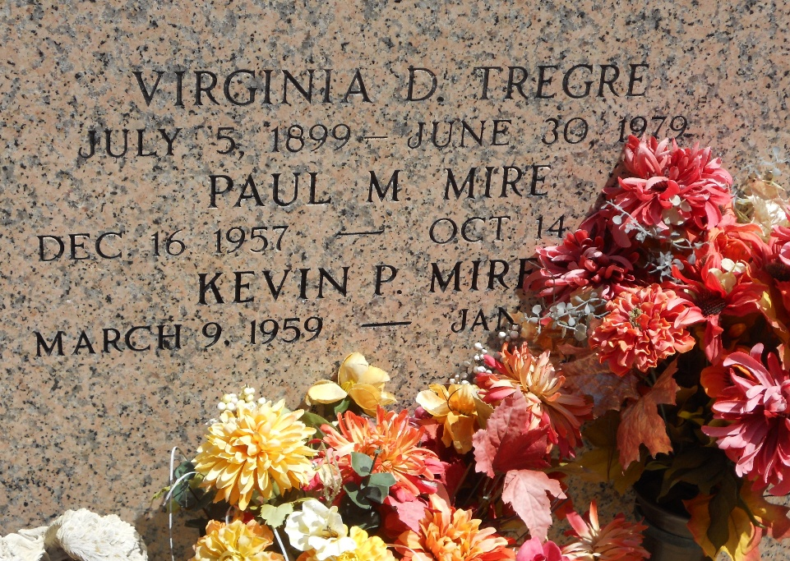
Photo by Team T-Lo

RESERVE – Paul Michael Mire, 46, a native of New Orleans and resident of Reserve, died Oct. 14.

He was the son of Jacqueline Tregre Mire, and the late Henry Mire, and brother of Vicki Pousson, Conne LeBlanc, Kevin and David Mire.

Services were Oct. 18 at St. Peter Catholic Church, Reserve, with interment at the church cemetery.

L’Observateur, LaPlace, Louisiana
October 20, 2004

