Tracy Lanette Mitchell
June 29, 1962 – March 6, 1993

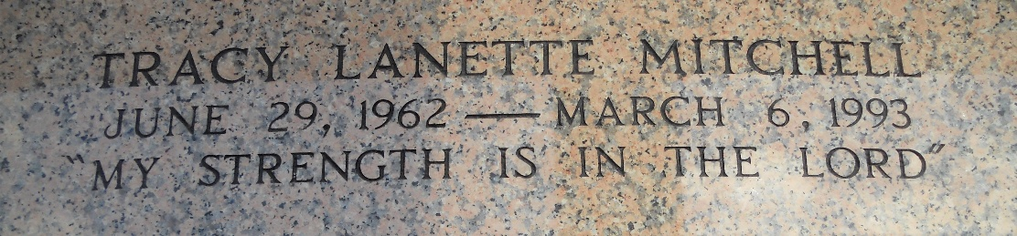
Photo by Team T-Lo

Tracy Lanette Mitchell, An Operator Technician For Marathon Petroleum Co., Died Of Cancer Saturday At M.D. Anderson Cancer Center In Houston. She Was 30.
Miss Mitchell Was Born In New Orleans And Lived In Laplace For Many Years. She Received A Bachelor Of Science Degree From Nicholls State University In Thibodaux.
Survivors Include A Daughter, Shanita Monique Castle; Her Mother, Audry Driver Mitchell; Her Father, John D. Mitchell; Her Grandmother, Gladys Mitchell Of Reserve; Three Sisters, Connie Mitchell Of Houston, Cheryl Mitchell Gaines Of New Orleans And Karen Mitchell Sterling Of Reserve; And Two Brothers, Kenneth Mitchell Of Houston And Gregory Mitchell Of Reserve.
A Funeral Will Be Held Today At 11 A.M. At Providence Baptist Church No. 1, 228 Pine St. In Laplace. A Visitation Will Be Held At 10 A.M. At The Church. Burial Will Be In St. Peters Mausoleum In Reserve. Earl Baloney And Son Mortuary Is In Charge Of Arrangements.
The Times-Picayune, New Orleans, Louisiana
March 11, 1993

