Craig Joseph Mollere
December 12, 1945 - May 20, 2022

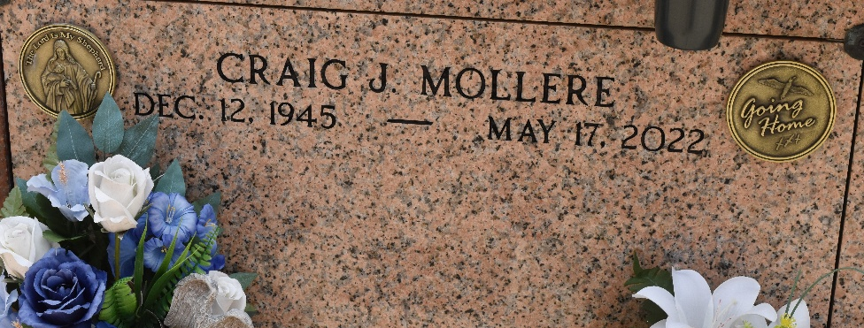

Craig Joseph Mollere passed away on May 17, 2022 at the age of 76. He was born in New Orleans, LA and was a lifelong resident of Reserve, LA. Craig loved the outdoors, fishing, crabbing and politics. He was the owner of Mollere Supply and loved St. John Parish. Craig never met a stranger. He loved spending weekends at the camp but most of all, time with his family.
Beloved husband of Alice Miller Mollere. Loving father of Crystal Rushing (Keith), Cindy Mollere, Chad Mollere (Stephanie), Chance Mollere (Sherry), Chase Mollere and Corrin Garcich (Brad). Grandfather of Mark Jr., Brandi, Brittany, Dennis, Timothy Jr., Mia, Jessica, Jaimie, Jaydon, Jaycen, Chanie, Chance II, Chaston, Mason, Colton, Aliya, Caiden, Carter and Stephen. Great-Grandfather of Joshua, Cane, Caleb, Nathan, Baylee, Beaux, Brooks, Emma, Owen, Jace, Jaycen, Jordan, Savannah, Mitchell, Justin, Caison, Cambrie, Piper, Peyton, Paige, Hunter, Clinton Jr., Arthur, and Holly. Son of the late Earline Weber Mollere and Wilbert Mollere. Brother of Keven Mollere (Janet) and Libby Englade (Norman). Also survived by nieces and nephews.
The Mollere family expresses their sincere thanks to Angelina Collier, Cabrina Davis NP and Heart of Hospice New Orleans.
Relatives and friends are invited to attend the Visitation and Funeral Mass at St. Peter Catholic Church, 1550 Hwy 44, Reserve, LA on Tuesday, May 24, 2022. Visitation from 10:00 a.m. to 12:00 p.m. followed by a Funeral Mass at 12:00 p.m. Interment in St. Peter Cemetery, Reserve, LA.
Millet-Guidry Funeral Home, LaPlace, Louisiana
May 21, 2022

