Earline (Weber) Mollere
June 20, 1924 – October 21, 2015

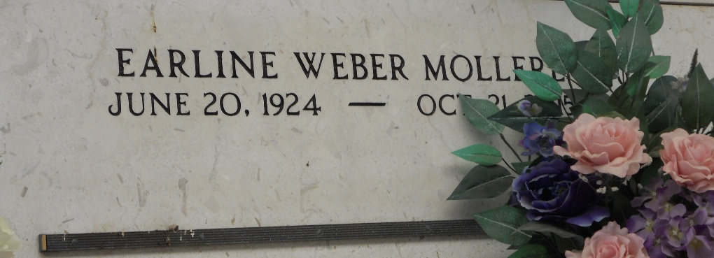
Photo by Team T-Lo

Earline Weber Mollere passed away peacefully on Wednesday, October 21, 2015 at 1:32 p.m. She was 91, a native and life-long resident of Reserve, LA.
Beloved wife of the late Wilbert J. 'Pee Wee, Buddy' Mollere. Mother of Craig Mollere (Alice), Kevin Mollere (Janet) and Libby Mollere Englade (Norman, Jr.). Daughter of the late Noe Weber and Norma Jacob Weber. Sister of the late Howard Weber (Elma), Noelie Weber Breaud (Felix), Norman 'Shot' Weber (Doris), Norma Weber, Jules Weber (Mabel), Hayes 'Creepy' Weber (Marilyn), and Helen 'Dolly' Weber Blouin. Grandmother of Christie, Erica, Halie, and Sadie Englade, Crystal (Keith Rushing), Cindy, Chad (Stephanie), Chance (Sherry), Chase, Corrin (Brad Garcich) and Aaron Mollere. Also survived by 18 great-grandchildren, 9 great-great grandchildren and many nieces and nephews.
She was the owner of Mollere Furniture Store in St. John the Baptist Parish.
The family would like to thank all of her care givers Katrina Pellissier, Jura Dell Veron, Janie Graffia, Johonna Triche, and St. Joseph Hospice, her nurse Dulce Favrot for their care and attention.
Relatives and friends are invited to attend the Funeral Service at Millet-Guidry Funeral Home, 2806 W. Airline Hwy, LaPlace on Monday, October 26, 2015 at 11:00 a.m. Visitation from 9:00 a.m. until 11:00a.m. Interment in St. Peter Cemetery.

The Times-Picayune, New Orleans, Louisiana
Oct. 22 to Oct. 25, 2015

