Wilbert J. Mollere
November 25, 1922 – April 27, 2003

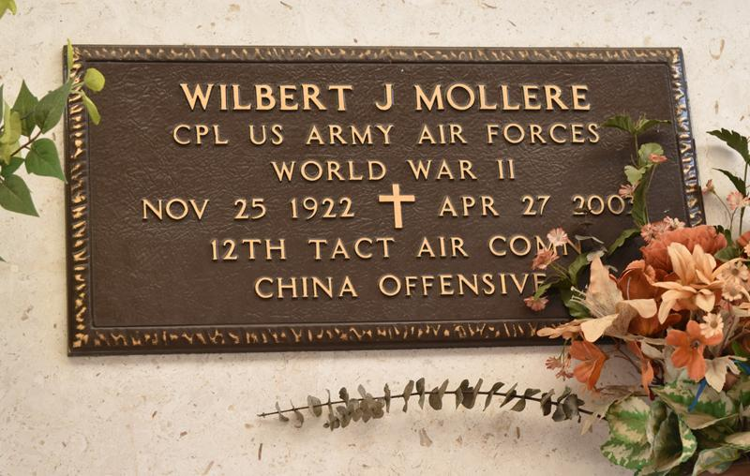

Wilbert J. (Pee Wee, Buddy) Mollere on Sunday, April 27, 2003 at 4:15 PM. Beloved husband of Earline Weber Mollere for 58 years. Father and father-in-law of Craig and Alice Mollere, Kevin and Janet Mollere and Norman and Libby Mollere Englade, Jr. Son of the late Ovide Mollere and Louise Stein Mollere Faucheaux. Stepson of the late Lionel Faucheaux. Brother of Cleve and Clifford Faucheaux, Emma Mury, Alice F. Vicknair, and the late Isabell Mollere and Anna M. Heltz. Grandfather of Chad, Chance, Chase, Corrin, and Aaron Mollere, Crystal M. Harry, Cindy M. Dufrense, Christie, Erica, Halie, and Sadie Englade. Also survived by 15 great grandchildren and 4 step great-grandchildren.
Age 80. A native of Lutcher, and a resident of Reserve for the past 58 years. He was the owner of Mollere Furniture Store in St. John the Baptist Parish and an Army Veteran of World War II.
Relatives and friends of the family are invited to attend services. Visitation at Millet-Guidry Funeral Home, 2806 West Airline Hwy, Laplace on Wednesday, April 30, 2003 from 8:30am-11:00AM followed by religious services in the funeral home chapel at 11AM. Burial in St. Peter Cemetery, Reserve.

The Times-Picayune, New Orleans, Louisiana
April 29, 2003

