Audrey (Falgoust) Monica
August 28, 1925 – May 7, 2008

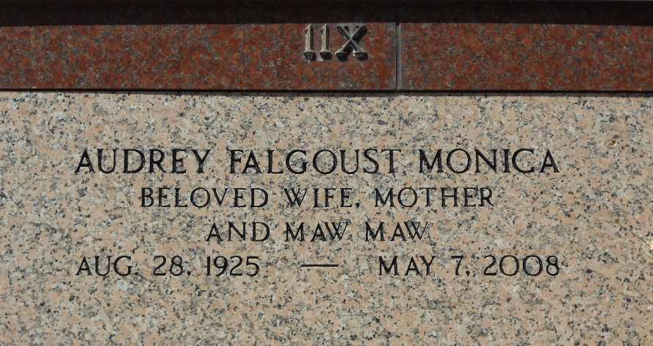
Photo by Team T-Lo

Audrey Falgoust Monica on Wednesday, May 7, 2008 at 5:30 a.m. Beloved wife of the late Joseph (Joe) Monica. Mother of Joey and wife, Rosie Monica, Ronald (Berlie) and wife, Christine Monica, Audrey (Tee) and husband, Carl Schutz, Ann (Noonie) and husband, Herbert (Brother) Hymel, Filippa (Fege) and husband, Gary Boe, Bernice and husband, Richard (Footy) Foret, State Rep. Nickie and wife, Dawn Monica and Angie and husband, R.J. Hales. Also survived by 28 grandchildren and 27 great-grandchildren.
Daughter of the late Armant and Bernice Falgoust. Sister of Lotsy Haydel, Frances Roccaforte, Shirley Mae Miano, Beryl Lebouef, the late Marcel and Pete Falgoust. Age 82 years. A native and a resident of Garyville, LA.
Relatives and friends of the family are invited to attend services. Visitation at MILLET-GUIDRY FUNERAL HOME, 2806 W. Airline Hwy., LaPlace, LA on Friday, May 9, 2008 from 6:00 p.m. to 9:00 p.m. and at St. Hubert Catholic Church, Garyville, LA on Saturday from 9:00 a.m. until 11:00 a.m. Followed by Religious Services at the Church at 11:00 a.m. Burial in St. Peter Cemetery, Reserve, LA.

The Times-Picayune, New Orleans, Louisiana
May 8, 2008

