Irene Taylor (Waguespack) Monica
January 15, 1934 – October 15, 2023

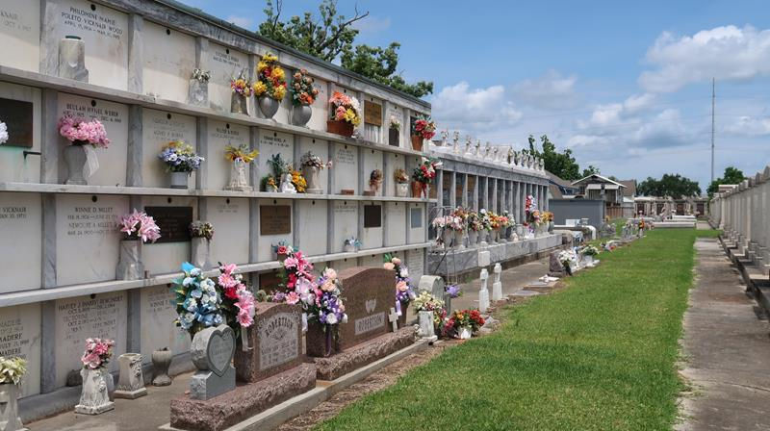

Irene Waguespack Taylor Monica passed away peacefully in her home on October 15, 2023 in the arms of her loving children, Doriane and Matthew, and their spouses, Stephen (Usner), and Bridgette (Karl Taylor).
Born on January 15, 1934 in Reserve, Louisiana, she was most proud of her days at Leon Godchaux Grammar and High Schools (Class of 1952), where she led the band as Head Majorette. Other high school accomplishments included the title of Sweetheart of LGHS, Queen of Carnival 1951, 4-H Club Officer, Gleanings Staff Member, Second Place Miss Reserve 1949, Homecoming Queen and Secretary-Treasurer of her Senior Class. She spoke often of the play she wrote her senior year and mostly, of the treasured friends ("The Girls") and boyfriends that she made throughout those years.
Before becoming a full time mother in 1970, she worked steadily for 17 years as executive secretary at Kaiser Aluminum in Gramercy and for the general manager of WVUE Television in New Orleans.
Her great joy in life was raising her two children, during which time she poured her talents into volunteer work at St. Clement of Rome and Johnny Bright Playground, creating memories for her children and their friends and building relationships that lasted a lifetime. In her work for New Life (the Archdiocese of New Orleans-sponsored pregnancy and counseling agency), she made many dear friends and found public relations to be her true calling. She successfully co-managed a family owned sugar plantation in Vacherie that had been in her father's family for hundreds of years. She had a love for writing and took several college courses at UNO, Dominican College, and Southeastern in Hammond. Her membership in a romance writers group led to writer's conferences, short courses and volunteering at the Tennessee Williams Literary Festival.
It would be remiss not to mention time devoted to helping care for her parents, husbands and other relatives with serious health problems. In 1990, following the death of her beloved husband of 36 years, Ernest Clyde Taylor, she married a former beau from Lutcher, Ronald Anthony Monica, with whom she enjoyed 28 years of traveling and socializing until his death in 2018. With Ron, she enjoyed her involvement in the Italian Club and time spent as President of LSU HSC's Faculty Wives Club. She is a two-time breast cancer survivor.
Of all of these accomplishments, however, the greatest was being "Mimsy" to her six grandchildren and great grandchild: Benjamin Walter Taylor, Chloe Leigh Usner, Vaughn Arthur Taylor, Emily Jean Usner, Molli Victoria Usner, Kirsten Usner McCall (Kevin), and Maren Amelia McCall.
She is preceded in death by her baby David Harold Taylor, her parents, Marie Lezian Vicknair and Benjamin Felix Waguespack, and her beloved brothers and sisters: Helen Waguespack Borne (Whitney), Benjamin Waguespack (Ezell), Walter Waguespack (Aurelie), and Carolyn Waguespack Monroe (Terry). She is survived by her children, grandchildren, great grandchild and her adored nieces and nephews. If she loved you, she loved you immensely.
In her later years, as dementia took its toll, those around her couldn't resist being swept up in her joyous demeanor. The family would like to extend special thanks to the nurturing caregivers who treated her with respect and dignity and allowed her to enjoy her last year in her home surrounded by the people and things that she held dear.
Visitation will be held on Friday, October 20th, at St. Clement of Rome Church, in Metairie, from 10am until 12pm with Mass from 12pm-1pm. Burial at St. Peter Cemetery, in Reserve, with a gathering to follow in Mandeville.

Nola.com
October 18, 2023

