Denise (LeBrun) Montegut
1886 – March 17, 1940

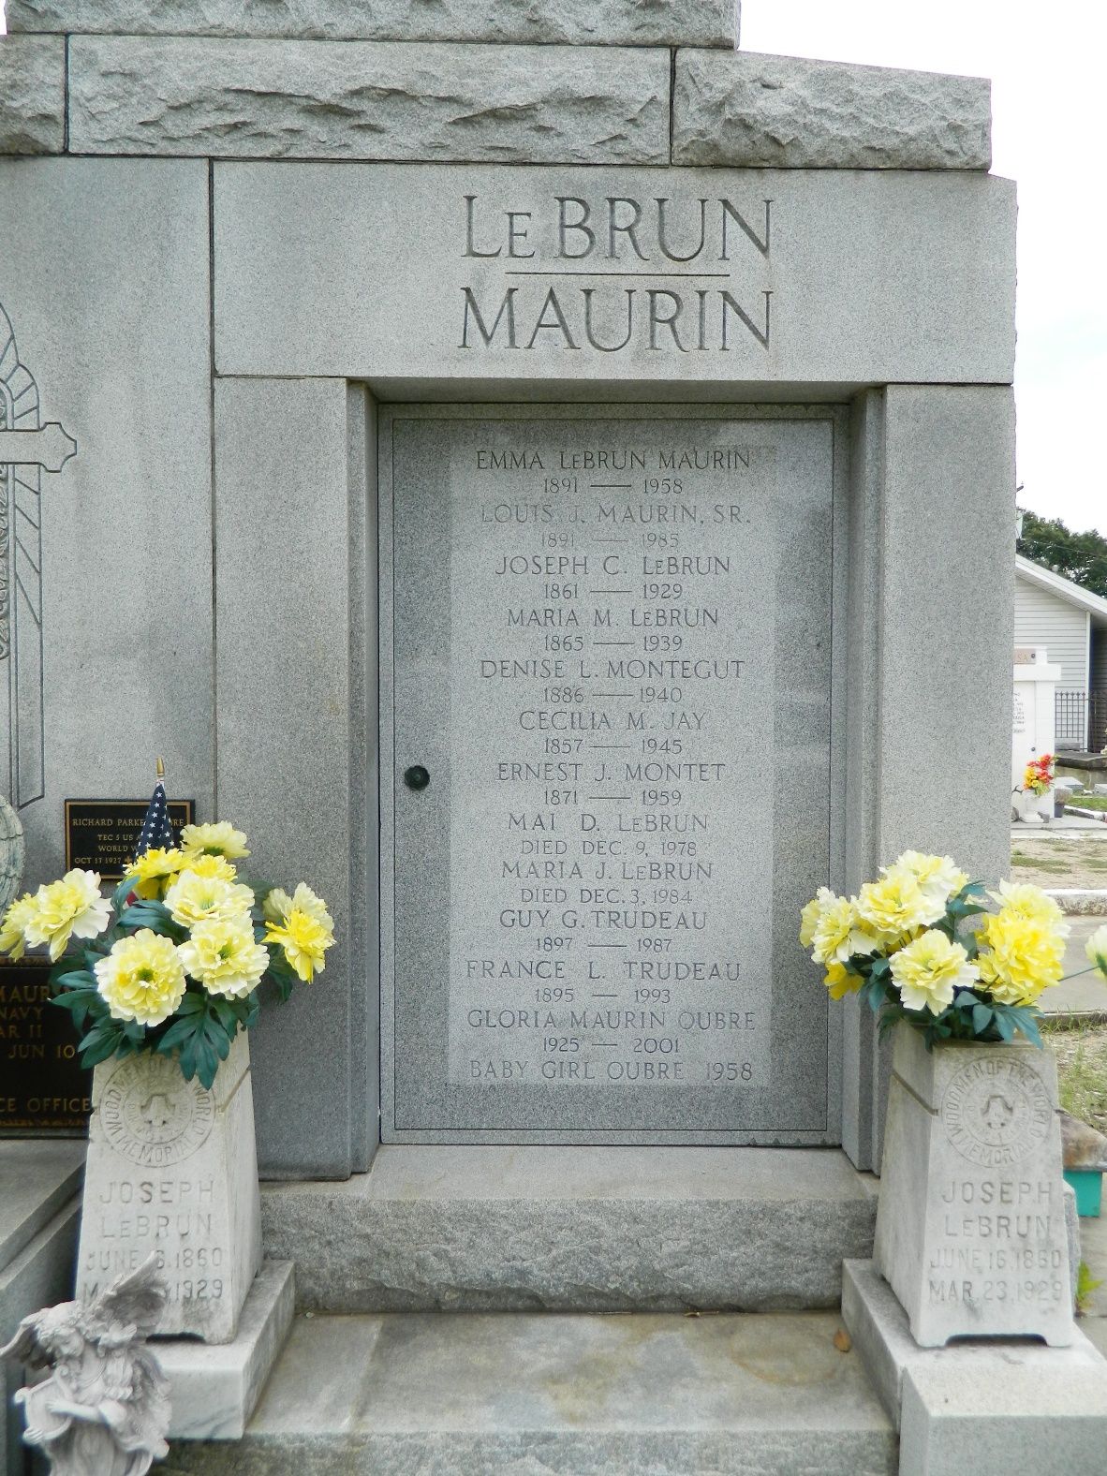

MONTEGUT-At Reserve, La, on Sunday, March 17, 1940, at 7:30 o'clock p.m., DENISE LEBRUN, beloved wife of the late James J Montegut, mother of Olga, James J Jr, Harold, Marcel, Carmen, Jeanne, Sidney and Claire Montegut, a native of St John the Baptist parish, aged 54 years.

Relatives and friends of the family are invited to attend the funeral, which will take place from the Jules Millet funeral home, Reserve, La, on Monday, March 18, 1940, at 4 o'clock p.m., followed by religious services at St Peter's Catholic church, Reserve, La. Interment in St Peter's cemetery.
The Times-Picayune, New Orleans, Louisiana
18 Mar 1940, p. 2

