Joseph Oswald Montegut III
November 5, 1959 - June 16, 2024

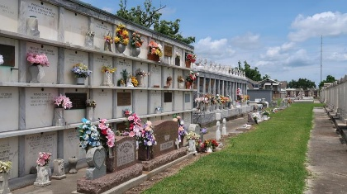

Joseph Oswald Montegut III, passed away on Saturday June 16, 2024 at the age of 64. “Ozzie”, as he was affectionately known, was a lifelong resident of Laplace.
He graduated from Jesuit High School of New Orleans and the University of New Orleans. He was self-employed and developed a talent for working with his hands. He worked on used cars, did home remodeling jobs, but he was best known for his air conditioning repair skills.
After learning the trade, he developed a following in the Laplace and reserve area, often responding after hours and on weekends to people in need of his services. He had a generous heart and will be greatly missed by those who knew him.
Son of the late Criswell Montegut and Minnette Millet Montegut. Brother of Christy Montegut, MD (Linda), Leo Montegut, Walton Montegut, MD and Roy Montegut (Jan). Uncle of Jason Montegut (Renae), Amanda Bourgeois (Todd), Christian Montegut, MD (Shelly), Frances Ledson (Tres), and Nicholas Montegut. Also survived by numerous cousins and friends.
Relatives and friends are invited to attend the Memorial Services on Wednesday , July 10, 2024, at St. Joan of Arc Catholic Church, 529 W. Fifth St., Laplace,LA. Visitation will be at the church from 10:30 a.m. to 12:00 noon, with the Memorial Mass to follow at noon. Internment will follow at St. Peter Cemetery in Reserve, LA.

Millet-Guidry Funeral Home, LaPlace, Louisiana

