Lucien Montegut
May 4, 1817 – January 29, 1901

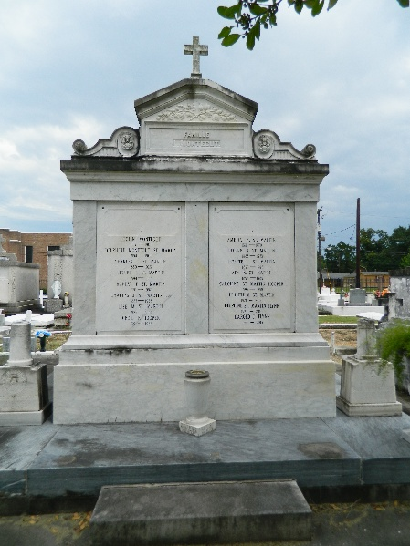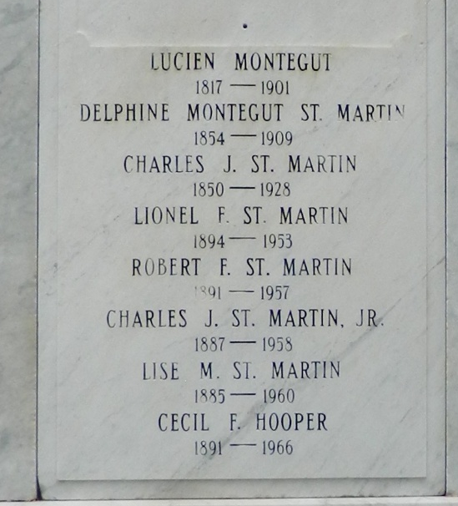

Lucien Montegut, one of the oldest and most widely-known planters of St John the Baptist Parish, died last Tuesday at his home in that parish. His death was sudden and without warning. He was about his usual business avocations when the call came. He had just signed a receipt for one of his tenants. He was 84 years of age, but was strong and well to the last, having given some attention to his garden the day before his death.
He was the owner of the New Era and Louque plantations, a large planter and grower of fine stock, in which he was an amateur. His interment took place in St Peter's cemetery on the 28th inst., the funeral being one of the largest that has ever taken place in the parish.
Lucien Montegut was born in the parish of St John the Baptist May 4, 1817. He was a son of Pierre Montegut and Margaret Lagroue. He was educated in private schools in his native parish. His first position after the completion of his education was as a deputy sheriff under Anacharsis Luminais, and he retained it for four years, resigning to occupy himself with planting, which he eventually made his lifework.
In his occupation as a planter he was very successful, and in spite of the ravages of the war and nine crevasses at various times he was enabled to leave each one of his nine children in a comfortable home on plantations of their own. Much of his substance was spent in works of charity, and he was known throughout the parish as the friend of the widow and the fatherless. His great sympathy for all forms of distress may have been due to the fact that he was left as a boy without a father, and at the age of 17 years was the head of a family, consisting of himself and one sister.
Deceased first married Delphine St Martin, a sister of the congressman of that name, having by that marriage two sons, Fergus and John, both now dead. He married a second time in 1831 Miss Amelia Haydel, and of that union seven sons and two daughters were born, Alphonse, Delphine, Lucien, Louis, Achille, Fernand, Amelie, Sidney and Albert. He would have celebrated the fiftieth anniversary of his marriage if he had lived until the 25th day of this month.
Mr. Montegut was a gentleman of the old school, and numbered his friends by the hundred. His funeral was very largely attended. The pallbearers were his five sons, Alphonse, Lucien, Fernand, Sidney and Albert, and Messrs. Charles St Martin, George St Martin, P Miaiaret, E J Caire and William J Hart.
The honorary pallbearers were: Judge Emile Rost, Messrs. James Clement, Rosemond Perret, Drausin Perret, Zenon Millet, Louis Chenet, E Soniat, Frank E Bernard, Edw. Sarpy, J L Ory, Chas. Lasseigne, Judge J L Gaudet, Agricole Armand, Dr L T Donaldson, Augustin Lasseigne, James Chenet, Felicien Waguespack, Elphege Alexandre, A P Dominique, Chas. Masicot, O Labarre, F Braud, R J Comeaux, Dr Elmore, Theodule Bourgeois Jr, John Blanchard, S Elfer, Albert J Laplace, L D Martin, George Lorio, F S Madere, Wilfred Bethancourt, E Haydel, A Keller, V Haydel, Ca Maurin, Jas. Le Brun, Horace Bougere, R Mears, Fernand Renaud, Ed Poche.
The Daily Picayune, New Orleans, Louisiana
3 Feb 1901, p. 9

