Pierre Fergus Montegut
1841 – November 3, 1898

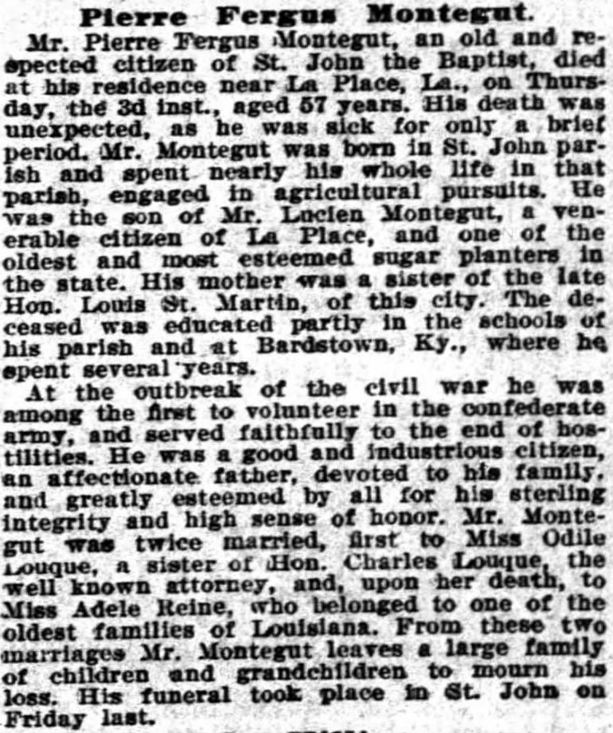

Times-Picayune, The (New Orleans, Louisiana)
November 6, 1898, p. 12

