Anita (Maurin) Montet
January 20, 1891 – May 15, 1942

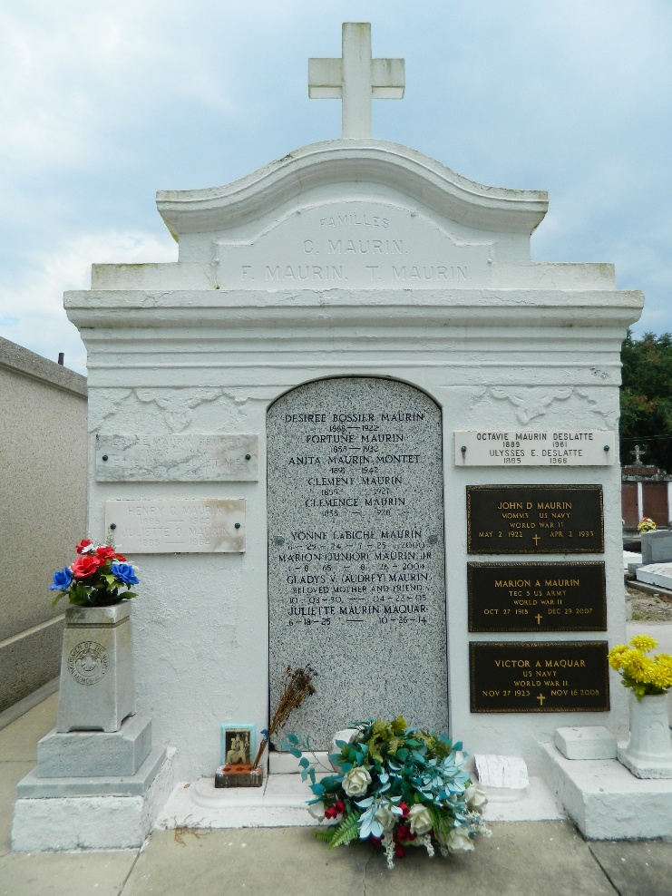

Anita Maurin, wife of Ernest Montet, died at her residence at 7825 Sycamore St, New Orleans, on Friday 15 May 1942 at 5 am.

She was the sister of Sidney Maurin of Laplace, Lousiana.

Services were Saturday 16 May 1942 at St Peter Church, Reserve, Louisiana, with interment in St Peter Cemetery.

Times-Picayune, New Orleans, Louisiana
November 17, 1959

