Ernest J. Montet
May 9, 1871 – November 16, 1959

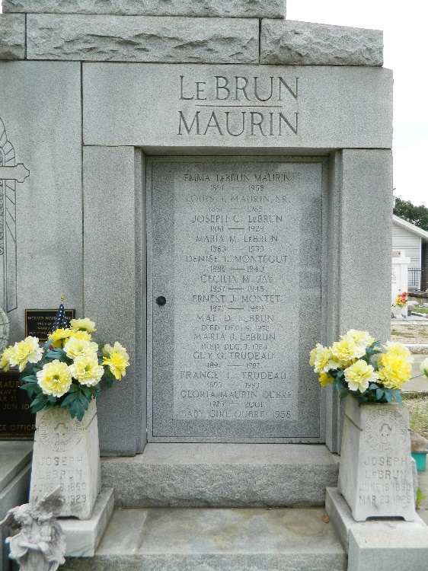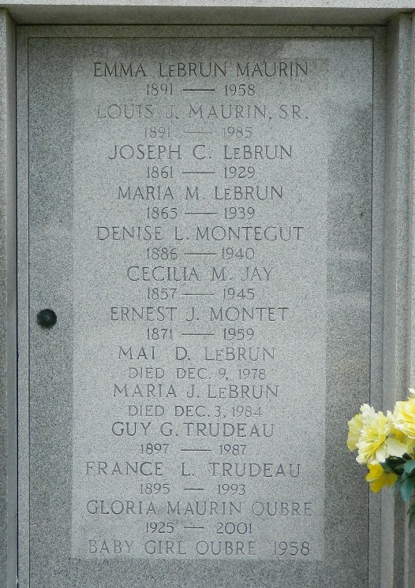

Ernest J. Montet, a native of Libourne, Gironde, France, immigrated to America in January of 1885 at age 14 and resided in Reserve, Louisiana, through 1899. He became a naturalized US citizen in March of 1893. At the end of the Spanish-American War, he went to the island of Cuba where he held various positions including agent for the Southern Pacific Company and private secretary to Auxiliary Bishop Broderick of the Diocese of San Cristobal de la Habana. He returned to the US briefly in 1907 and then moved to Chile. In 1910 he returned to the United States, returning to Cuba later in the year as an employee of the Singer Sewing Machine Company. During his overseas years, he made several visits to Reserve until 1918 when he returned to the United States permanently.
He married about 1921 to Anita Maurin and they lived in New Orleans. Mr. Montet died Monday, 16 Nov 1959 at an age of 88 years. He was the brother of the late Mrs. Maria LeBrun, Mrs. Cecilia Jay and Edmond Montet and the uncle of Mrs. Guy G. Trudeau, Maria, and Mai D. LeBrun, and the late Mrs. L. J. Maurin Sr and Mrs. J. J. Montegut Sr.
Funeral services were held Wednesday 18 Nov 1959 at St Peter Church, Reserve, with interment in St Peter Cemetery.

Times-Picayune, New Orleans, Louisiana
November 17, 1959

