Adrienne (Tregre) Montz
October 15, 1885 – July 6, 1960

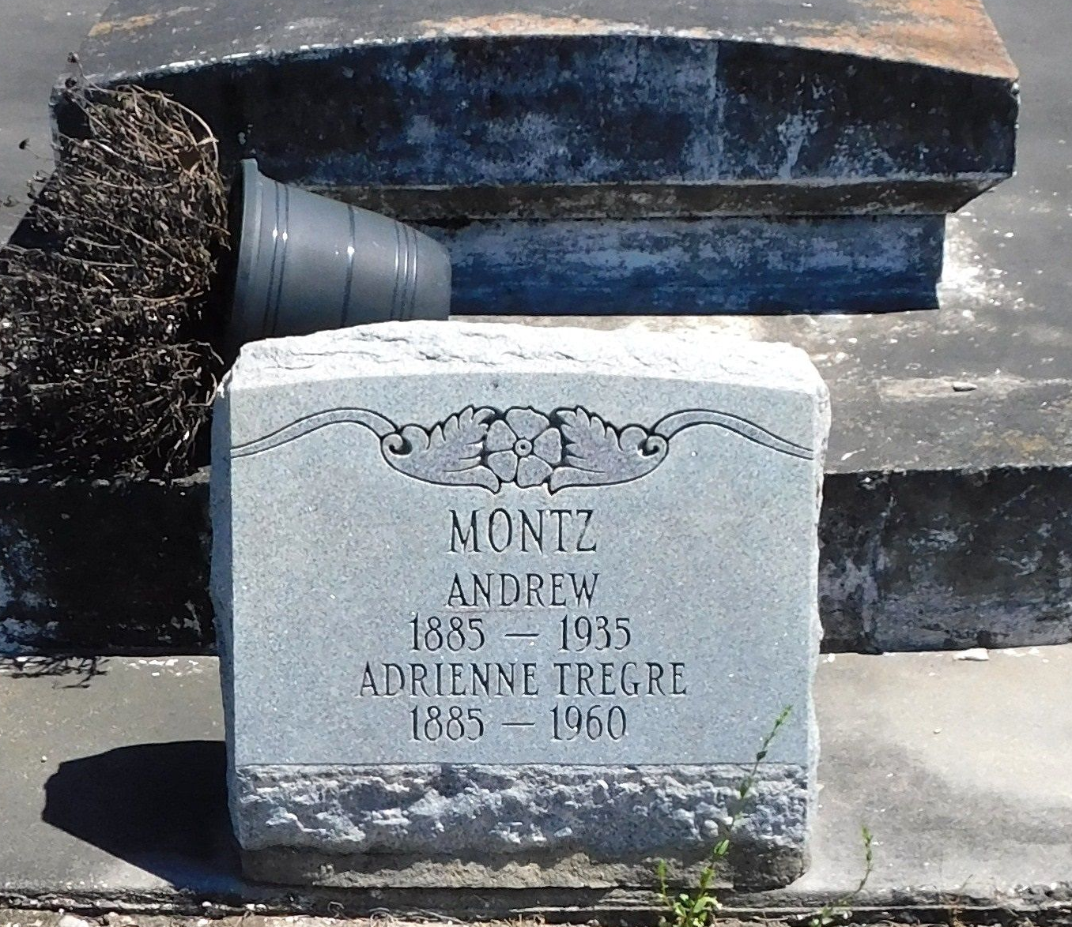
Photo by Mary Agnes Hammett

Adrienne Tregre, wife of the late Andrew Montz, died in Reserve, Louisiana, on Wednesday 6 Jul 1960 at 1:00 a.m. at age 74 years. She was a native of Lions, Louisiana, and a resident of Reserve.
Survived by her children Mrs. J. A. Cambre Jr. of Reserve, Mrs. Audrey Frantz of Kenner, Louisiana, Andrew O. Montz of Arabi, Louisiana, J. C. Montz of Lake Charles, Louisiana, and the late Nolan J. Montz. Also survived by five grandchildren.
Services were from Millet Funeral Home, Reserve, on Thursday, 7 Jul 1960 followed by Mass at St Peter Church, Reserve. Interment in St Peter Cemetery, Reserve.

Times-Picayune, New Orleans, Louisiana
July 7, 1960

