Barbara Ann (Terrio) Montz
November 13, 1936 – March 5, 2009

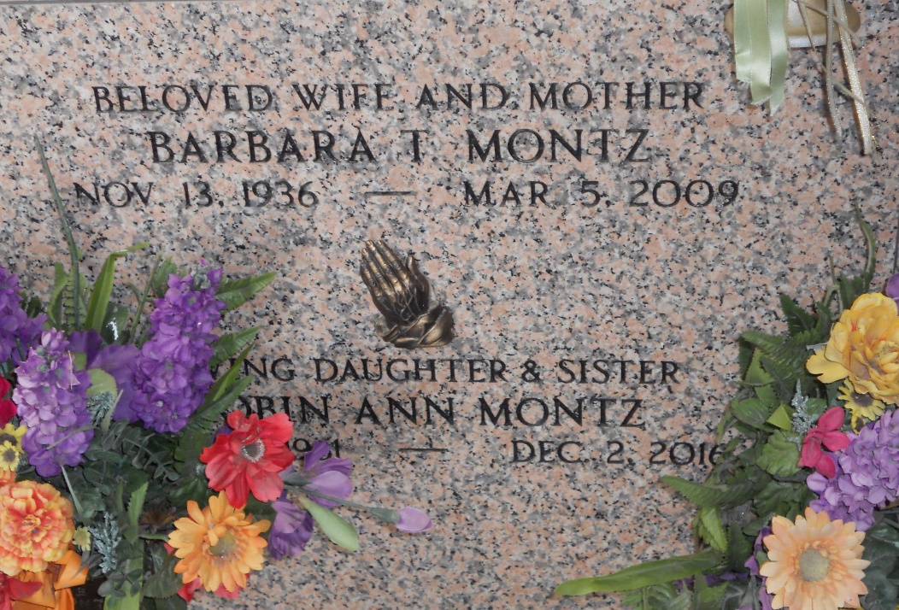
Photo by Team T-Lo

Barbara Terrio Montz on Thur. March. 5, 2009 at 3:45 am. Beloved wife of Helmuth (Bosco) Montz. Mother of Lisa Hurrelbrink, Robin Montz, Kristine Orillion and Scott Montz. Also survived by 7 grandchildren.
Daughter of the late Hubert and Edna Terrio. Sister of Margaret Poche, Beryl Rome and Anna Berthelot. Age 72. A native and resident of Reserve, La.
Relatives and friends are invited to attend services. Visitation at Millet-Guidry Funeral Home, 2806 W. Airline Hwy. LaPlace, La., on Saturday, March 7, 2009 from 10:00 am to 11:45 am. Followed by religious services at St. Peter Catholic Church, Reserve, La. at 12:00 noon. Burial in St. Peter Cemetery.

Times-Picayune, New Orleans, Louisiana
March 6, 2009

