Bernice Justine (Lambert) Montz
September 25, 1919 – February 5, 2005

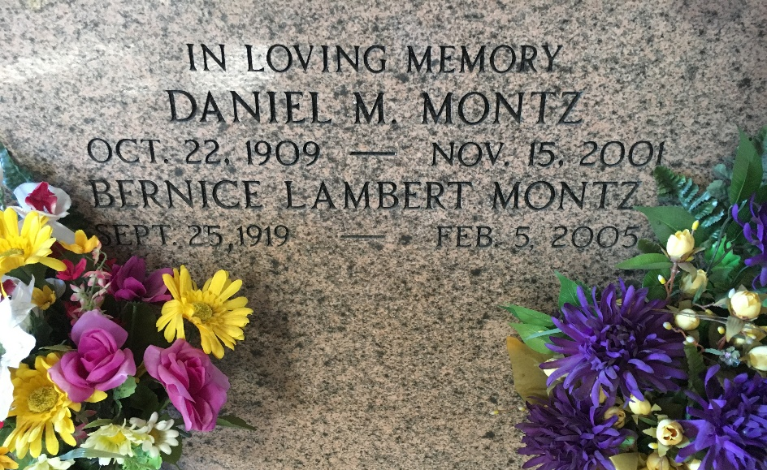
Photo by Team T-Lo

Bernice ''Bonnie'' Lambert Montz on Saturday, February 5, 2005 at 9:42 AM. Beloved wife of the late Daniel M. Montz for 62 years. Loving mother of Polly Bourg, Karen Landry and Lorna Boies. Mother-in-law of Leo Bourg and the late Richard Landry. Grandmother of Lisa Specht and her husband Mark, Troy Landry, Holly Hinchman and her husband George and Sarah Boies. Great grandmother of Dustin, Hunter and Hailey Specht and Layla and Gavin Hinchman.
Daughter of the late Joseph O. and Poliska Barbier Lambert. Sister of the late Lillian, Mabel, Lillie, Hilda, Carrie, Vergie, Joe, Sidney, Fallon and Evan Lambert. Also survived by a host of nieces and nephews. Age 85 years. A native of St. Rose and a resident of Norco, LA for the past 60 years.
Visitation at Sacred Heart of Jesus Church, 401 Spruce St., Norco on Monday, February 7, 2005 from 1PM until 2PM followed by a Mass of Christian Burial at 2PM. Burial in St. Peter Church Cemetery in Reserve, LA. In lieu of flowers, Masses preferred. Arrangement by Milliet-Guidry Funeral Home.

Times-Picayune, New Orleans, Louisiana
February 6, 2005

