Camille (Bourgeois) Montz
January 15, 1916 – February 17, 2004

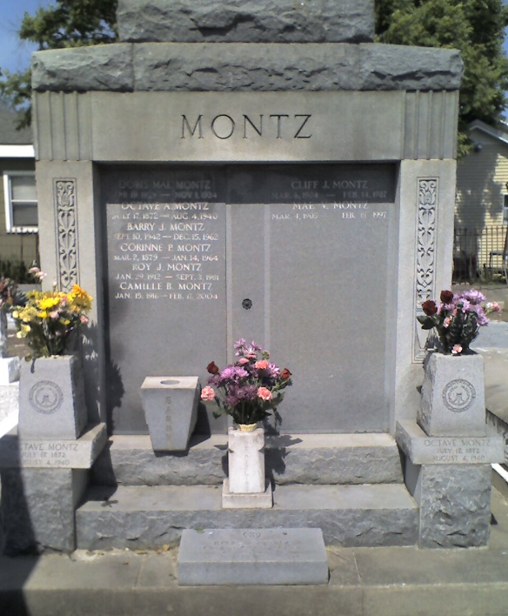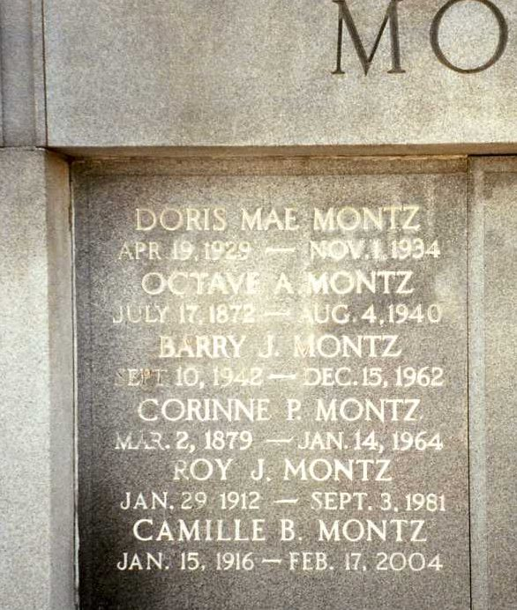
Photo by Dwayne Montz

Mrs. Camille Bourgeois Montz, 88, of Erath, La. passed away at 7:05 PM on Tuesday, February 17, 2004 at Eastridge Nursing Home in Abbeville, La. Mrs. Montz was the beloved wife of the late Roy J. Montz. She was a native of Lutcher, La., former resident of LaPlace, La. for sixty years and a resident of Erath for the past ten years.
Born on January 15, 1916, Mrs. Montz was the daughter of the late Aloysius Bourgeois and Emily Adolph Bourgeois. Survivors include her son, Dwayne A. Montz and wife Mary of Dayton, Ohio; son, Rodney C. Montz and wife Penny of Erath, La; daughter, Carolyn A. Perego and husband Edgar of Estelline, Texas; sister, Emma Feucht of LaPlace, La; eight grandchildren, three great-grandchildren, and many nieces and nephews.
Besides her parents and husband, Mrs. Montz was preceded in death by a son, Barry J. Montz; four brothers, Nolan, Adolph, Junius, Herbert “Scoot” and three sisters, Yvonne Foret, Evelyn Snipes and Inez Babin.
A Mass of Christian Burial will be celebrated on Saturday, February 21, 2004, at 1:00 PM at St. Joan of Arc Catholic Church in LaPlace, La. Interment will follow in St. Peter Cemetery in Reserve, La. The Rev. William €Billy � O'Riordan will officiate at the service. A gathering of family and friends will be at Millet-Guidry Funeral Home in LaPlace, La, on Friday, February 20, 2004 from 5:00PM to 9:00PM. A Rosary will be prayed at 6:00PM Friday. Visitation will continue on Saturday, February 21, 2004 from 9:00AM until time of service.
Sincere and deepest appreciation is extended by the family to the Eastridge Nursing Home staff, the 2nd floor nurses at Abbeville General Hospital and Dr. Ronald Lahasky for the wonderful care given to their mother.

Times-Picayune, New Orleans, Louisiana
February 19, 2004

