Carl Joseph Montz Sr.
April 9, 1912 – December 9, 2005

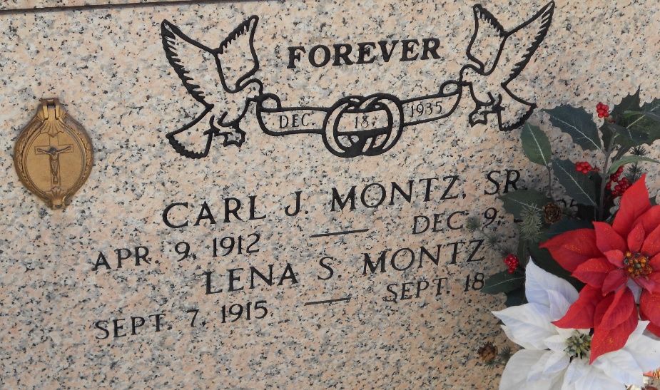
Photo by Team T-Lo

Carl J. Montz, Sr. passed away peacefully at his home on Friday, December 9, 2005. He was the beloved and devoted husband of Lena Stein Montz. They would have celebrated their 70th Wedding Anniversary on December 18, 2005.
Loving father of Betty Duhe, Sandra Lasseigne, Carl Montz, Jr., Katherine DeSilvey, Elizabeth Laiche, Perry Montz and Terry Montz. Father-in-law of Judy Montz, David DeSilvey, Douglas Laiche, Bridget Montz and the late Oswald Duhe. Treasured Paw-Paw to 17 grandchildren and 15 great-grandchildren.
He was preceded in death by his parents, Pierre Rene and Marie Montz; and 7 brothers and sisters. He was employed by Godchaux Sugar Refinery for 45 years and served as Justice of the Peace in St. John Parish from 1977 to 1990. Age 93 years. He was a native and lifelong resident of Reserve, LA.
Family and friends are invited to attend the services. Visitation at St. Peter Catholic Church, Reserve, LA on Monday, December 12, 2005 from 9:00 a.m. until 11:00 a.m. Followed by Religious Services at the Church at 11:00 a.m. Burial in Church Cemetery.
The family wishes to thank Sonya McCrary, Mary Thomas, Annie Bell and the staff of Synergy Home Care for their help in caring for our father. Special thanks also to Dr. Jose Cusco for his excellent care and support to the family.
In lieu of flowers, donations may be made to the Servant of God Eyraud Sainthood Fund or Education Fund in his name. Arrangements by Millet-Guidry Funeral Home, LaPlace, LA.

Times-Picayune, New Orleans, Louisiana
December 10-11, 2005

