Cecile (Candies) Montz
October 8, 1899 – June 10, 1969

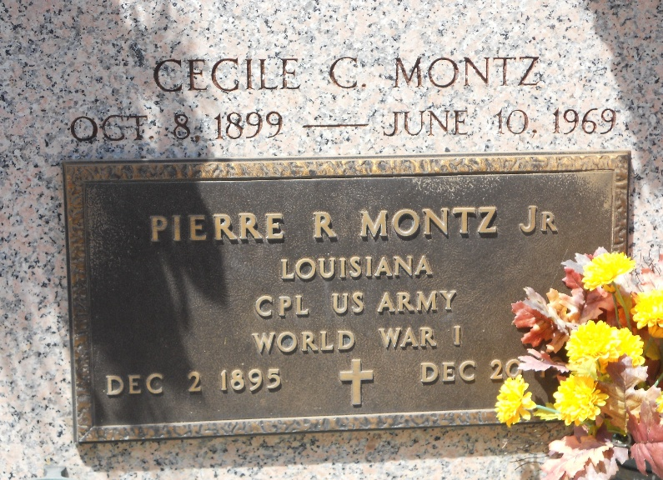
Photo by Team T-Lo

Age 69 years, a native of Des Alemands, Louisiana, a former resident of New Orleans, and a resident of St Bernard Parish, Louisiana, for the past 19 years.

Wife of Pierre Rene Montz Jr, mother of Clyde A Christen. Daughter of the late Ben Candies and Elizabeth Graham.

Services were Thursday 12 Jun 1969 at St Peter Church, Reserve, Louisiana, with interment in the Church Mausoleum.

Times-Picayune, New Orleans, Louisiana
June 11, 1969

