Charles Montz
June 19, 1837 – November 4, 1900

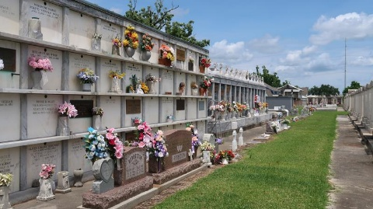

Charles Montz, son of Symphorien Montz and Justine Lasseigne, was born 19 Jun 1837 and baptized 15 Oct 1837 in St John the Baptist Church, Edgard, LA [Baptism Book 6, p 234].
His obituary is found in Le Meschacébé, issue of 10 Nov 1900, p 4.
[Translated from French] Last Monday accompanied by his relatives and friends, the remains of Charles Montz, who died yesterday, were taken to St Peter Church. A terrible disease struck this excellent citizen a few days before with consequences which had not been considered very serious at first but against which science was powerless.
Endowed with a fine intellect, a very high and upright character, but with simplicity of manners and tastes that moved him away from the bustling crowd, Charles Montz spent a long existence in this parish without ever trying to be noticed, fleeing the turmoil of life to quietly enjoy the peace of home. He needed little to be happy and vain honors had no temptation for him.
He was a typographer for a long time attached to the Meschacébé of old, while it was headed by MM. Dumez and Bellow. He remained unmarried and was aged about 64 years.
Charles is listed in the index to St Peter Church Funeral Register 2, p 285, as Benjamin Charles Montz.

Researched by Dwayne Montz

