Cliff J. Montz
March 6, 1904 – February 14, 1987

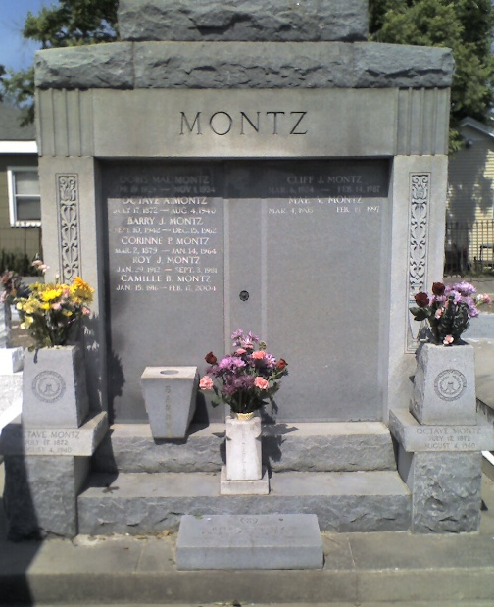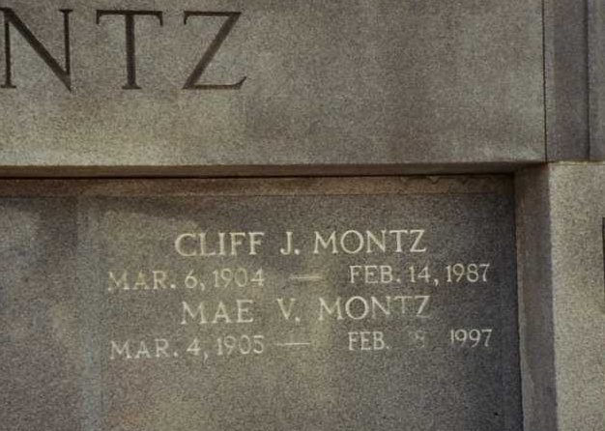
Photo by Dwayne Montz

Cliff J. Montz of Laplace, a local businessman who was a descendant of German pioneers who settled this area in the 18th century, died at 2:15 pm Saturday, 14 Feb 1987 at River Parishes Hospital, Laplace, following a heart attack. He was 82 years old.
Mr. Montz, a gregarious and popular man long known to everyone as "Cliff", was a lifelong resident of Laplace. He was the son of Corinne Eliska Perilloux and Octave Alexis Montz. Mr. Montz was married to Mae Vicknair of Garyville.
In his younger years, he worked in his father's dry goods store, The O Montz Dry Goods Store in Laplace. Later, in the 1930s, he opened a tavern where local men would gather to relax and play cards. The bar was and still is known as "Cliff's Bar". Located in Old Laplace, it is on Main St, near the Airline Hwy. When prohibition ended, Cliff Montz served the first bottle of Jax Beer across the bar. He was a grocery man and bartender to the people of the town. As his business grew, he hired many local men to help him.
A man of friendly nature, he knew nearly everyone in town and he was generous to his many friends. Sometimes he gave free food from his grocery store for neighbors in need.
Mr. Montz is survived by his wife, a son, Warren "Smokey" Montz, a daughter, Jane M DesRoches, a sister, Mrs. France Jacob, six grandchildren, Timothy O. Montz, April M. Campbell, Marsha M. Town, Steven A. Montz, Cary A. DesRoches and Stuart E. DesRoches, as well as four great-grandchild-ren.
He was predeceased in death by a daughter, Doris Mae Montz, two brothers, Roy and Allen Montz, two sisters, Mrs. Eliska Madere and Mrs. Leona Hebert. "Cliff is missed by his wife, his children and his family of friends", said a member of the family. "He will long be remembered as one who extended his hand in friendship and enjoyed the company of mankind". His voice echoes the familiar phrase of charity: "How do you do! My name is Cliff Montz! It's nice to meet you!"
L'Observateur, LaPlace, Louisiana
26 Feb 1987

