Corrine Marie Montz
May 12, 1874 – December 13, 1931

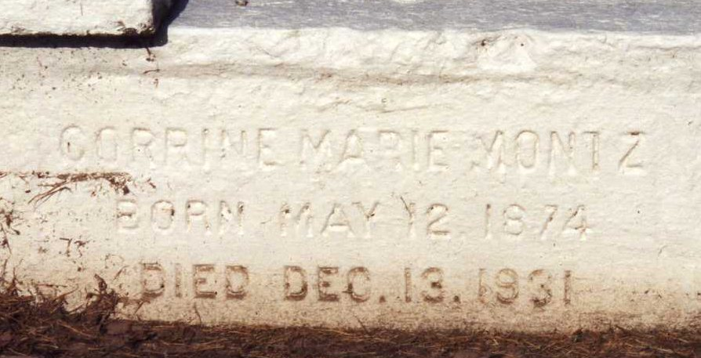
Photo by Dwayne Montz

Miss Corrine Montz died at her residence in Laplace, Louisiana, on Sunday, 13 Dec 1931 at 6:10 pm.

She was the sister of William, Octave, George and Armand Montz and Mrs. Elias Madere, Mrs. George Lambert, Miss Blanche Montz and Sister Mary Genevieve of the Dominican Order.

Services were Monday 14 Dec 1931 at St Peter Church, Reserve, Louisiana, with interment in St Peter Cemetery.
The Times-Picayune, New Orleans, Louisiana
14 Dec 1931

