Dana Antoine Montz
November 8, 1873 – August 8, 1941

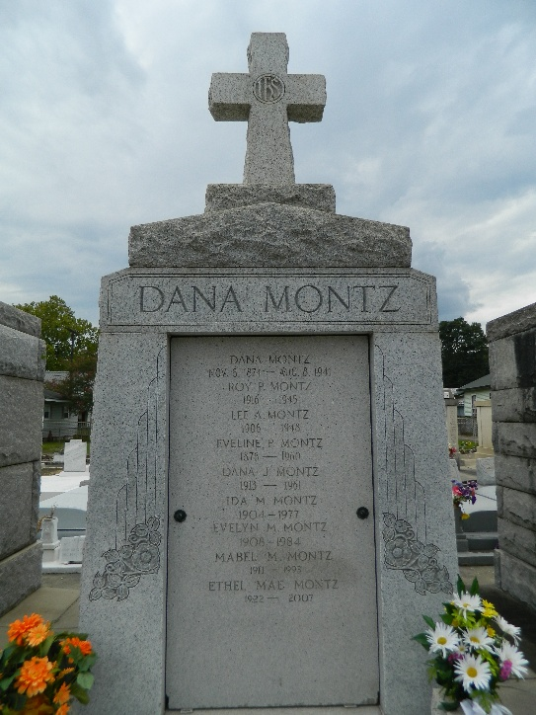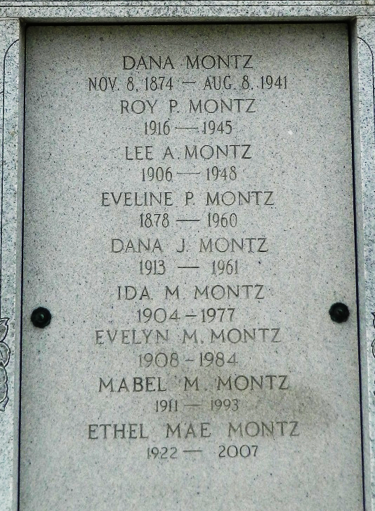

Dana A. Montz Sr. died at Reserve, Louisiana, on Friday, 8 Aug 1941 at 1:00 am at age 67 years and 9 months.

He was the husband of Evelyn Perret and the father of Ida, Evelyn, Mabel, Ethel Mae, Lovincy, Lee, Dana Jr. and Roy P Montz and the brother of Mrs. Wallace Williams.

Services were Sunday, 10 Aug 1941 at St Peter Chuarch, Reserve, Louisiana, with interment in St Peter Cemetery.

Times-Picayune, New Orleans, Louisiana
August 9, 1941

