Dana J. Montz
February 10, 1913 – November 10, 1961

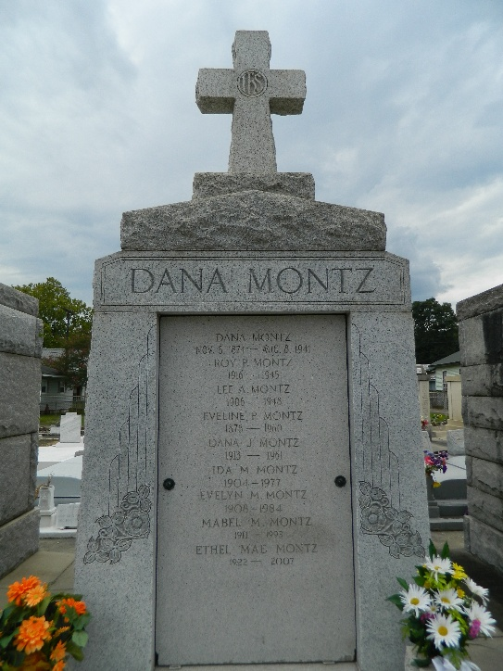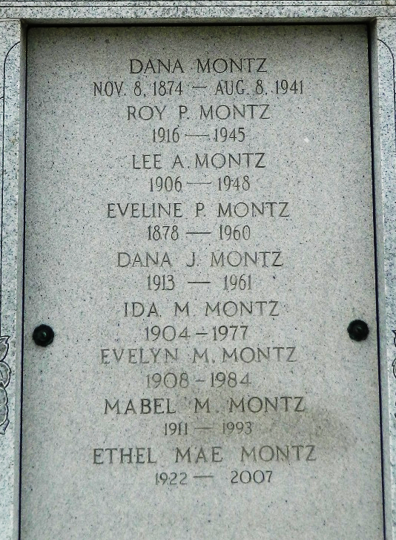

Age 48 years, 6 months, a native and resident of Reserve, Louisiana.

Son of the late Dana A Montz and Evelyn Perret and brother of Ida, Evelyn, Mabel, Ethel Mae and Lovincy Montz and the late Lee A. Montz and Roy P. Montz.

Services Saturday 11 Nov 1961 at St Peter Church, Reserve, Louisiana, with interment in St Peter Cemetery, Reserve.

Unknown source

