Daniel Maurice Montz
October 22, 1909 – November 15, 2001

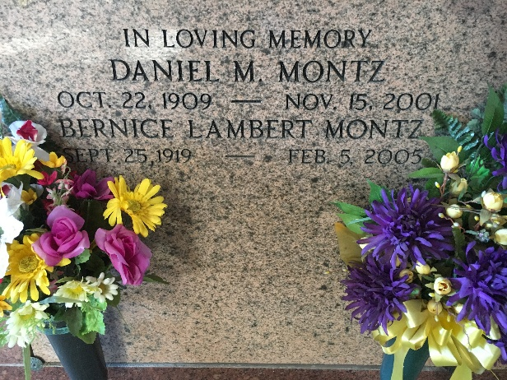
Photo by Team T-Lo

Daniel M Montz, a retired instrument mechanic for Shell Oil Co, died Thursday, 15 Nov 2001 at Metropolitan Hospice in Metairie, Louisiana. He was 92, a native of Lions, Louisiana, and had lived in Norco, Louisiana, for more than 60 years.
Survivors include his wife, Bernice "Bonnie" Lambert Montz; three daughters, Polly Bourg, Karen Landry and Lorna Boies; three brothers, Elmore, Quincy and Floyd Montz; two sisters, Yoland Landry and Pearl Madere; four grandchildren and four great grandchildren.
A Mass was said Saturday at Sacred Heard of Jesus Catholic Church in Norco. Interment was in St Peter Cemetery, Reserve, Louisiana.
The Times-Picayune, New Orleans, Louisiana
November 16, 2001
**

NORCO - Daniel M. Montz, 92, a native of Lions and resident of Norco for more than 60 years, died Nov. 15.
He was the husband of Bernice "Bonnie" Lambert Montz for 61 years and father of Polly Bourg, Karen Landry and Lorna Bouise. He was the son of the late Maurice and Virginia Cambre Montz and brother of Yolande Landry, Pearl Madere, Elmore, Quincy and Floyd Montz and the late Lillian Griffin and Vivian Montz. He is survived by four grandchildren and four great-grandchildren.
He was an instrument mechanic at Shell Oil for 42 years and was retired for 33 years.
Services are today at 10:30 a.m. at Sacred Heart of Jesus Catholic Church, Norco, with interment at St. Peter Cemetery, Reserve. Visitation starts at 8:30 a.m.
L'Observateur, LaPlace, Louisiana
November 17, 2001

