Doris Mae Montz
April 19, 1929 – November 1, 1934

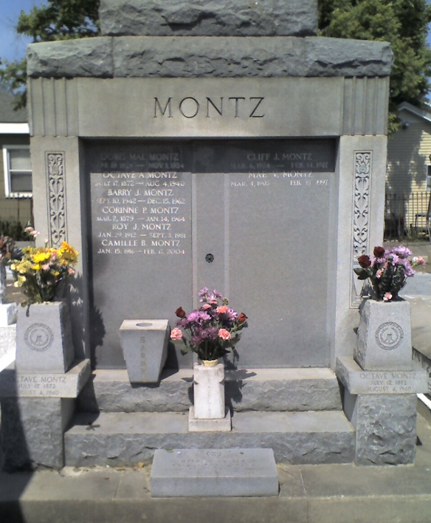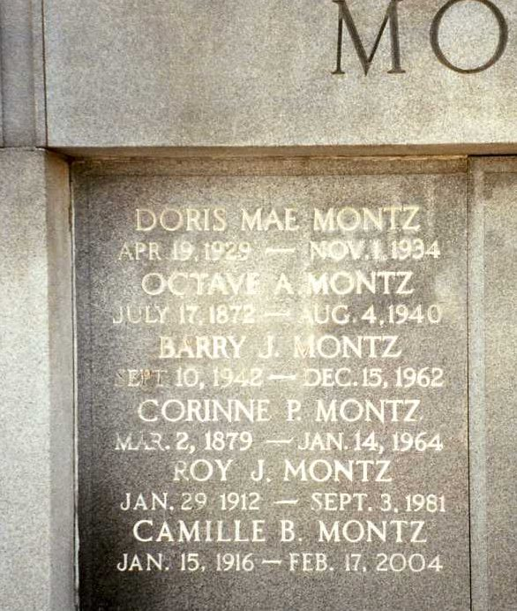
Photo by Dwayne Montz

MONTZ - At Hotel Dieu [Hospital] at 11:15 a.m. Thursday, November 1, 1934, DORIS MAE MONTZ, aged 5 years, beloved child of Mr. and Mrs. Clifford Montz of Laplace, La.

Funeral will be held at St Peter's Catholic church at Reserve, La, at 4 p.m. Friday, November 2, 1934, with interment in St Peter's Cemetery.

Times-Picayune, New Orleans, Louisiana
November 2, 1934, p. 2

