Emma Eva (Millet) Montz
November 12, 1872 – March 12, 1960

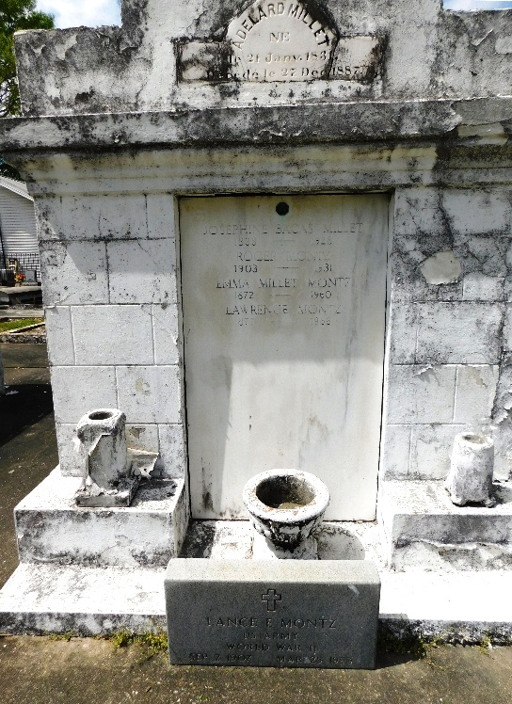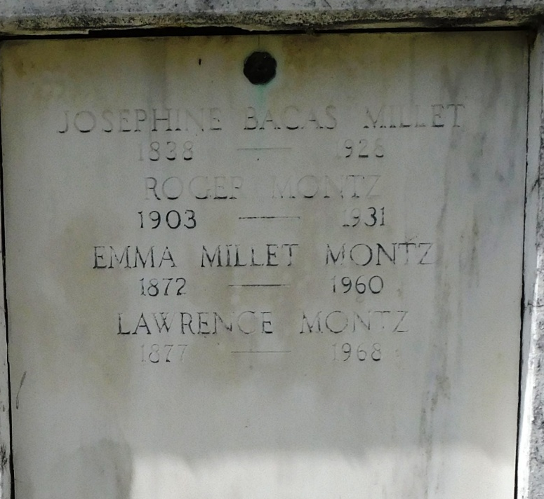
Photo by Mary Agnes Hammett

Emma Eva Millet, wife of Lawrence Montz, died at her residence in Lions, Louisiana, on Saturday, 12 Mar 1960 at 9 o'clock PM.
She was the mother of Mrs. Eunice Baudouin of Hahnville, Louisiana, Mrs. Claudia Cambre and Mrs. Yvonne Cambre of Laplace, Louisiana, Lance Montz of Garyville, Louisiana, and Roy Montz of Kenner, Louisiana. Also survived by nine grandchildren and 10 great grandchildren. Age 87 years, a native and resident of Lions.
Relatives and friends of the family are invited to attend the funeral services which will take place from Millet Funeral Home, Reserve, Louisiana, on Monday 14 Mar 1960 followed by Mass at St Peter's Church, Reserve. Interment in St Peter Cemetery, Reserve.

Times-Picayune, New Orleans, Louisiana
March 14, 1960, p. 2

