Ernestine (Heltz) Montz
February 17, 1855 – February 18, 1943

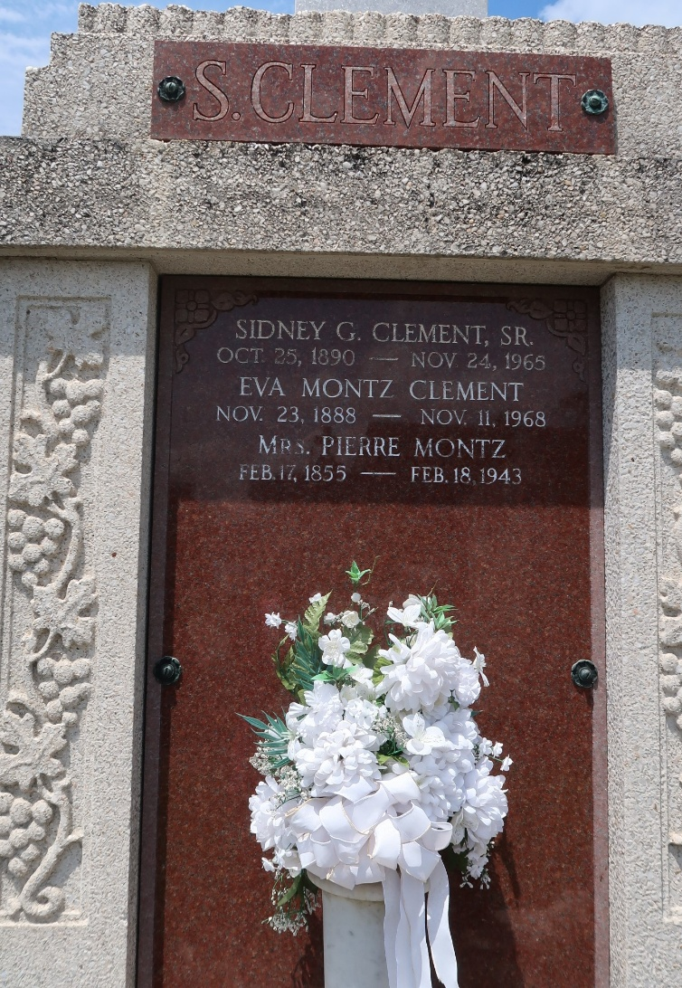

Mrs. Pierre Montz was born Ernestine Heltz, a daughter of Jean Heltz and Philonese Conrad.
OCTOGANARIAN PAID LAST TRIBUTE
After a long lingering illness, Mrs. Widow Pierre Montz died at her residence at Lions, LA, this parish, last Thursday night, February 18, at 9:45 o'clock.
On Saturday morning her funeral services were held at St Peter's Catholic Church in the presence of a large concourse of relatives and friends who had come to pay their last respect to the venerable old lady. Deceased, who had celebrated her 88th birthday on the eve of her passing into eternity, was a native of St John Parish and a lifelong resident of Lions.
She is survived by one son, Maurice Montz of Lions; three daughters, Mrs. John Williams of Reserve; Mrs. Sidney Clement of Lions; Mrs. J. Leonce Hotard of Jennings; 36 grandchildren, 21 great-grandchildren and one great-great-grandchild.
L'Observateur, LaPlace, Louisiana
27 Feb 1943

