Ethel Mae Montz
February 20, 1922 – April 23, 2007

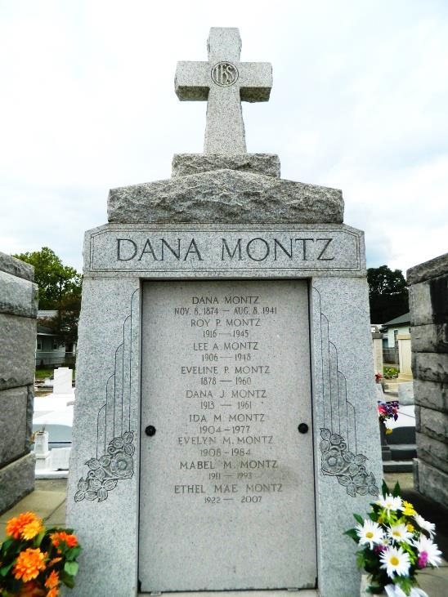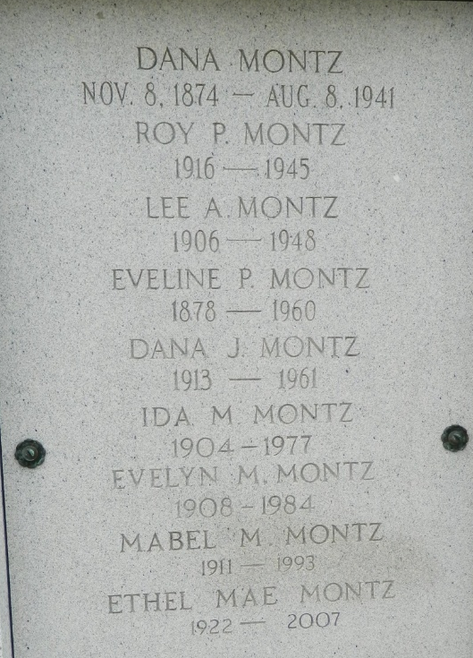

Ethel Mae Montz, on Monday, April 23, 2007 at 11:40 pm. Beloved daughter of the late Dana and Eveline Perret Montz. Sister of the late Lovincy, Lee, Roy, Dana Jr., Ida, Evelyn and Mabel Montz. Aunt of the late Rose Mae Montz Valdin and Carroll Montz. Great aunt of Danna Asaro, Larry Valdin and Brenda LeBlanc. Age 85. A native and resident of Reserve.
Relatives and friends are invited to attend services. Visitation at St. Peter Catholic Church, Reserve on Friday, April 27, 2007 from 9 am to 10 am followed by religious services at the church at 10 am. Burial in church cemetery. Arrangements by Millet-Guidry Funeral Home, Laplace

Times-Picayune, The (New Orleans, Louisiana)
Wednesday, April 25, 2007

