Eveline (Perret) Montz
1878 – September 7, 1960

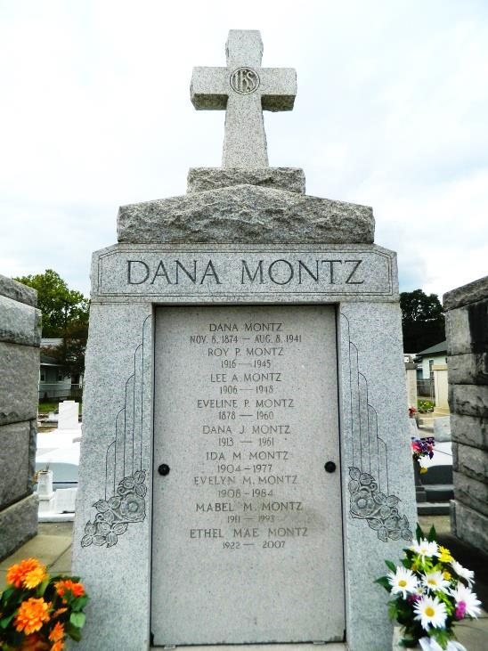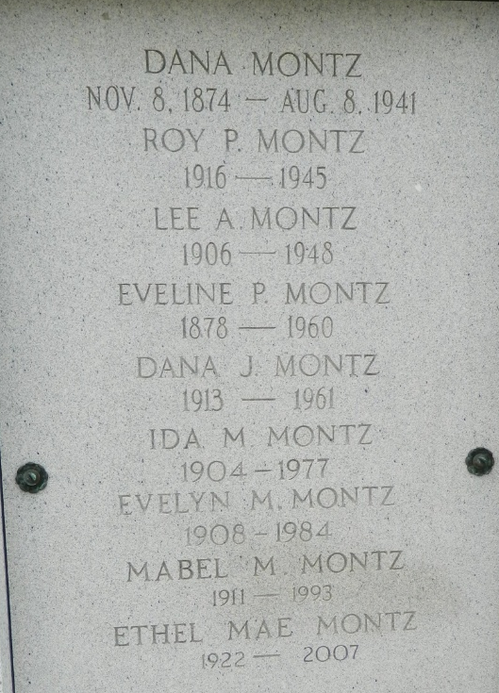

MONTZ-At her residence, Reserve, La, on Wednesday September 7, 1960, at 6:05 o'clock p.m., EVELINE PERRET, wife of the late Dana Montz; mother of Lovincy, Ida, Evelyn, Mabel, Dana and Ethel Mae Montz and the late Lee and Roy P Montz; sister of the late Justine Perret; also survived by 2 grandchild-ren and 3 great grandchildren; age 82 years; a native of Laplace, La, and a resident of Reserve, La.

Relatives and friends of the family are invited to attend the funeral which will take place from Millet Funeral Home, Reserve, La, on Friday, September 9, 1960 at 9:30 o'clock a.m., followed by religious services at St Peter's church. Reserve, La. Interment in St Peter cemetery.

Times-Picayune, The (New Orleans, Louisiana)
September 8, 1960, p. 2

