Evelyn M. Montz
October 26, 1908 – February 26, 1984

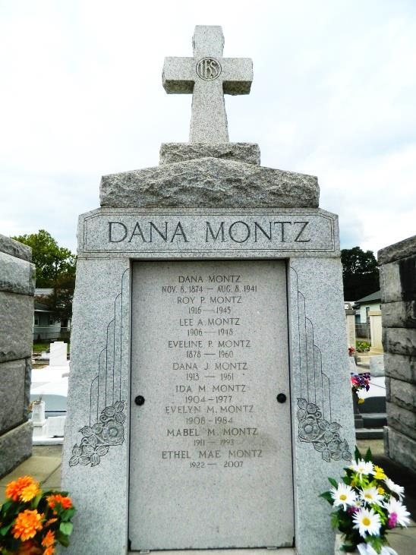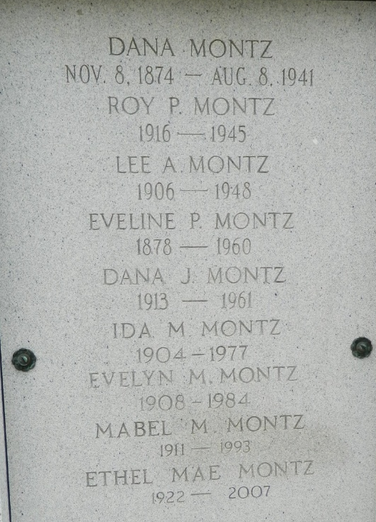

Evelyn M Montz died Sunday 26 Feb 1984 at 6:30 am at age 75 years.

She was a native and resident of Reserve, Louisiana, and the daughter of the late Dana Montz and Evelyn Perret. She was the sister of Mabel Montz and Ethel Mae Montz, both of Reserve, and the late Lovincy, Ida, Lee, Dana and Roy Montz.

Services were Tuesday, 28 Feb 1984 at St Peter Church, Reserve, with interment in St Peter Cemetery, Reserve.

Times-Picayune, The (New Orleans, Louisiana)
February 27, 1984

