Harry Joseph Montz Sr.
September 13, 1914 – April 28, 1985

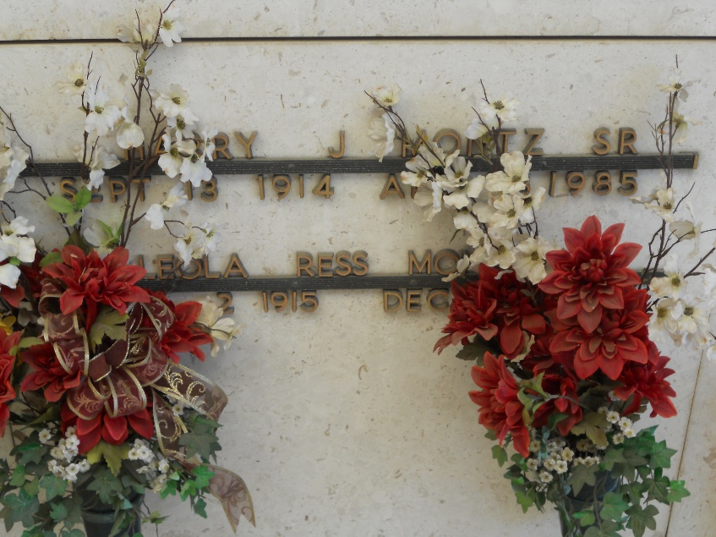
Photo by Team T-Lo

Harry J. Montz, Sr., on Sunday, April 28, 1985 at 8:30 a.m., beloved husband of Leola Ress Montz, son of the late Eddie Montz Sr and Berthe Hymel Montz, father of Harry J Montz, Jr., Mrs. Wayne (Sally) Reddick, Mrs. Carroll (Nancy) Guillot, all of Reserve, Norma Jean Cole of Laplace, Theresa Smith of Boiling Springs Lake, NC, brother of Helmuth, Ruffin and Edward Montz, Mrs. Michel (Florence) Vicknair, Mrs. Leon (Evelyn) Graugnard, all of Reserve, Mrs. Paul (Ruby) Roussel of Metairie and the late Eddie Montz Jr., also survived by 10 grandchildren, age 70 years, a native of Edgard, LA and a resident of Reserve for the past 64 years.
Relatives and friends of the family also former employees of Godchaux Sugars and the St John's Sheriff Dept are invited to attend the funeral services from Millet Funeral Home, Reserve, LA on Tuesday, April 30, 1985 at 10:00 a.m., followed by religious services at St Peter Catholic Church. Interment in Church Cemetery, Reserve, La.

Times-Picayune, New Orleans, Louisiana
April 29, 1985, p. 35

