Helmuth Rene Montz
July 18, 1909 – July 18, 1990

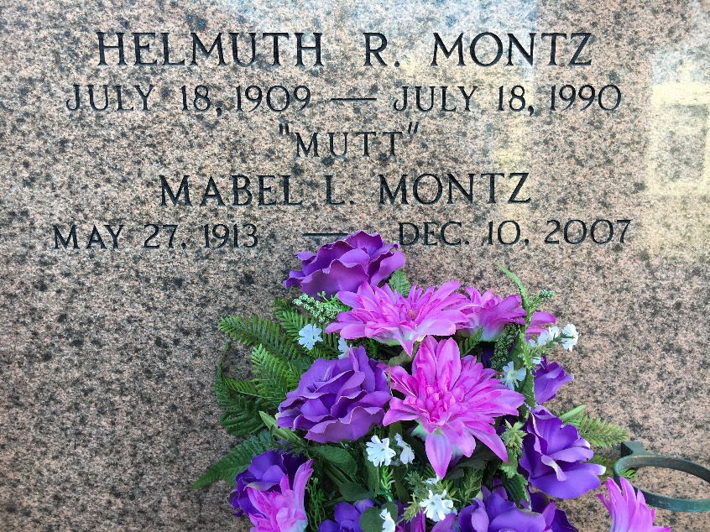
Photo by Team T-Lo

Helmuth R. (Mutt) Montz on Wednesday, July 18, 1990 at 7:50 p.m.
Beloved husband of Mabel Lasseigne. Father of H. J. (Bosco) Montz of Reserve, La, Larry (Boogie) Montz of LaPlace, La, and Janet M. Dubis of Donaldsonville, La. Also survived by 10 grandchildren, 1 great grandchild, 2 brothers, 4 sisters and preceded in death by 2 brothers and 1 sister. Age 81 years. A native and resident of Reserve, La.
Relatives and friends of the family are invited to attend the funeral services at MILLET-GUIDRY FUNERAL HOME 2806 WEST AIRLINE HWY, Reserve, La, on Saturday, July 21, 1990 followed by Religious Services at St Peter Catholic Church, Reserve, La, at 11:00 a.m. Interment in Church Cemetery.

Times-Picayune, New Orleans, Louisiana
July 20, 1990

