Lawrence Montz
August 5, 1877 – February 7, 1968

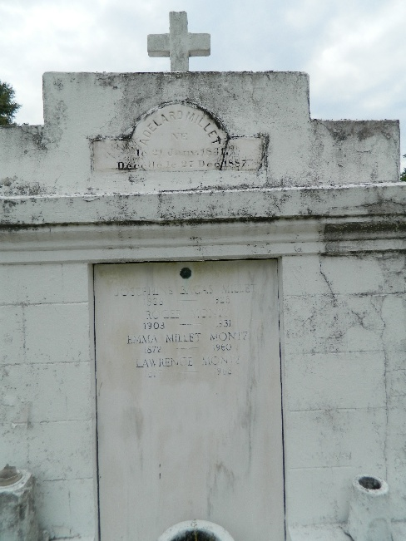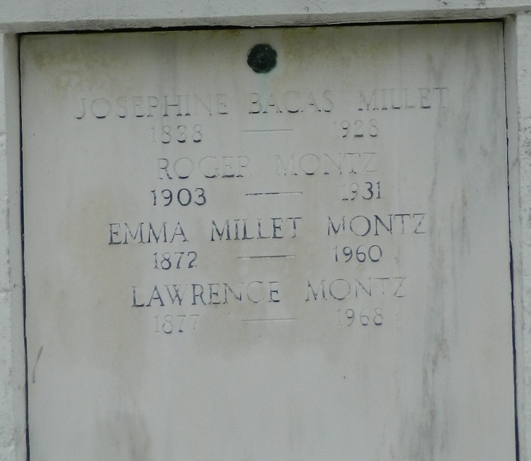

Lawrence Montz died on Wednesday 7 Feb 1968 at 1:40 o'clock PM.

Husband of the late Emma Millet and father of Mrs. Eunice Baudouin of Hahnville, Louisiana, Mrs. Claudia Cambre and Mrs. Yvonne Cambre of Laplace, Louisiana, Lance Montz of Garyville, Louisiana, Royal Montz of Kenner, Louisiana, and the late Roger Montz. Also survived by 10 grandchild-ren and 19 great grandchildren. A native of Lions, Louisiana, and a resident of Reserve, Louisiana.

Relatives and friends of the family are invited to attend the funeral services from Millet Funeral Home, Reserve, on Friday 9 Feb 1968 with religious services at St Peter's Church, Reserve. Interment in St Peter's Cemetery, Reserve.
The Times-Picayune, New Orleans, Louisina
8 Feb 1968, p. 2

