Lena (Stein) Montz
September 7, 1915 – September 18, 2007

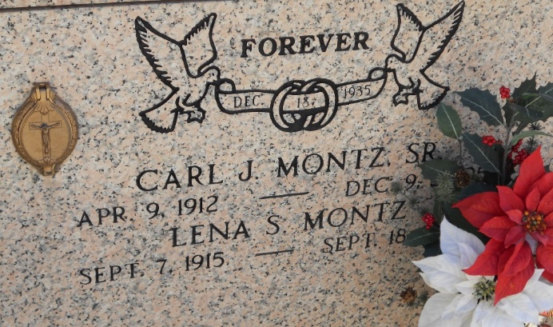
Photo by Team T-Lo

Lena Stein Montz departed this life surrounded by her family to join her beloved husband, Carl J. Montz, Sr. in eternal rest on Tuesday, September 18, 2007, at the age of 92. She was a loving wife, mother, grandmother and great-grandmother.
She was the devoted mother of Betty Duhe, Sandra Lasseigne, Carl J. Montz, Jr., Katherine DeSilvey, Elizabeth Laiche, Perry Montz and Terry Montz. Mother-in-law of Judy Montz, Bridget Montz, David DeSilvey, Douglas Laiche, the late Oswald Duhe and Wayne ""Whitey'' Lasseigne. She adored her 17 grandchildren, 16 great-grandchildren, and was anxiously awaiting the birth of her next great-grandson.
Survived by her sister, Elucia S. Duhe. Preceded in death by her husband; her parents: Elucia and Louis Stein, Sr.; and 7 brothers and sisters. She was a lifelong resident of Reserve, LA and will be greatly missed by all who knew her.
Family and friends are invited to attend the services. Visitation at St. Peter Catholic Church, Reserve, LA on Friday, September 21, 2007 from 9:00 a.m. to 11:00 a.m. Followed by Religious Services at the Church at 11:00 a.m. Burial in Church Cemetery.
The family wishes to thank Annie Bell for her help in caring for our mother. Special thanks to Dr. Jose Cusco for his care and support to the family and to the employees of Canon Hospice, especially Sandy Oliveri, Shannon Dwoark and LaToya Darensburg. Thanks also to Mary Thomas and Sonia McKarry.
In lieu of flowers, donations may be made to the Servant of God Eyraud Sainthood Fund or Education Fund in her name. Arrangements by MILLET-GUIDRY FUNERAL HOME, LaPlace, LA.

Times-Picayune, New Orleans, Louisiana
September 20-21, 2007

