Leo Bernoville Montz
October 2, 1902 – June 4, 1962

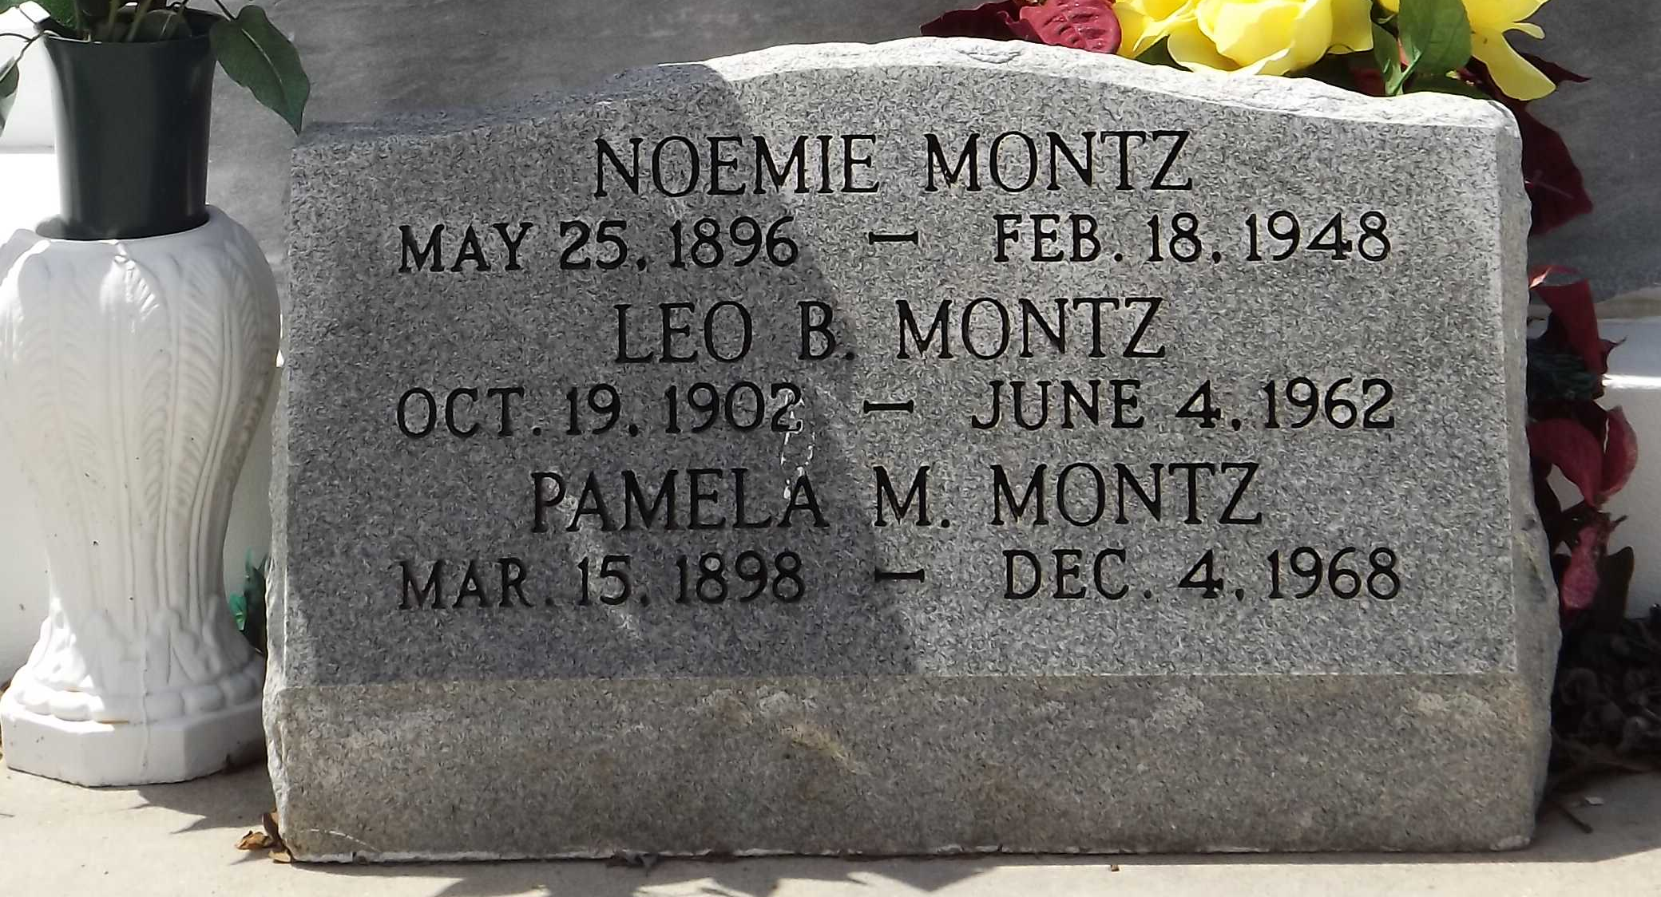
Photo by Mary Agnes Hammett

Leo Bernoville Montz died on Monday, 4 Jun 1962, at 12:35 o'clock p.m. at age 59 years.

He was the brother of Pamela Montz and the son of the late Camille Montz and Blanche Madere. He was a native and resident of Montz, Louisiana.

Relatives and friends of the family, also employees of National Gypsum Co of Good Hope, Louisiana, are invited to attend the funeral services from the late residence, Montz, Louisiana, on Tuesday 5 Jun 1962. Interment in St Peter Cemetery, Reserve, Louisiana.

Times-Picayune, New Orleans, Louisiana
May 24, 1979

