Leola M. (Ress) Montz
August 2, 1915 – December 8, 1994

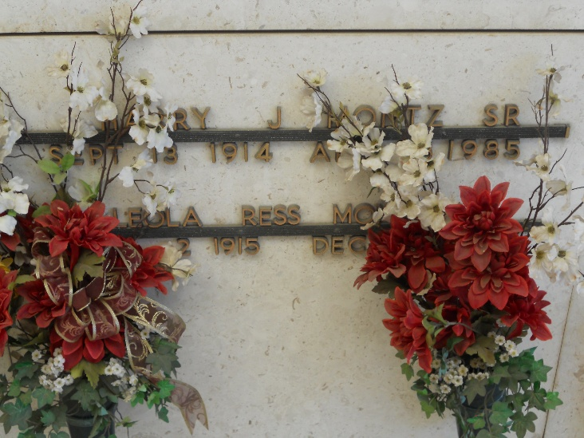
Photo by Team T-Lo

Maria Leola Ross Montz, retired founding director of the St. John the Baptist Parish Council on Aging, died of respiratory failure Thursday at John Muir medical Center in Walnut Creek, Calif. She was 79.
Mrs. Montz was born in Reserve and for the past six years lived in Sterling and Great Falls, Va., Missouri City, Texas, and Walnut Creek.
Survivors include four daughters, Sally Reddick and Nancy Guillot of Reserve, Norma Jean Cole of LaPlace and Theresa McCarthy of Walnut Creek; a son, Harry Joe Montz of Reserve; a sister, Freida Vicknair of Reserve; a brother, Fred Ress Jr. of Baton Rouge; 10 grandchildren and six great-grandchildren.
Visitation will be Monday from 5 to 9 p.m. and Tuesday at 8 a.m. at Millet-Guidry Funeral Home on Airline Highway in LaPlace. A funeral will be held Tuesday at 9 a.m. at St. Peter Church on River Road and West Seventh Street in Reserve. Burial will be in St. Peter Cemetery in Reserve. Millet-Guidry Funeral Home is in charge of arrangements.

Times-Picayune, New Orleans, Louisiana
December 10, 1994

