Mabel (Lasseigne) Montz
May 27, 1913 – December 10, 2007

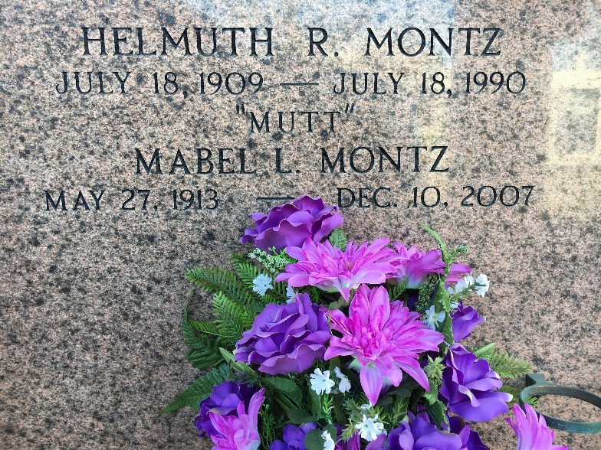
Photo by Team T-Lo

Mabel Lasseigne Montz on Monday, December 10, 2007 at 7:10 a.m.
Beloved wife of the late Helmuth (Mutt) Montz. Mother of H. J. (Bosco) Montz, Larry (Boogie) Montz and Janet Montz Dubis. Daughter of the late Wallace and Noelie Haydel Lasseigne. Also survived by 10 grandchildren and 9 great grandchildren.
Special thanks to Dr. Bailey, Twin Oaks Nursing Home and St. Catherine Hospice.
Age 94 years, a native and resident of Reserve, LA.
Relatives and friends of the family are invited to attend services. Visitation at Millet-Guidry Funeral Home, 2806 W. Airline Hwy., LaPlace, LA on Thursday, December 13, 2007 from 9a.m. to 11 a.m. followed by Religious Services at the Funeral Home Chapel at 11 a.m. Burial in St. Peter Cemetery, Reserve, LA.

Times-Picayune, New Orleans, Louisiana
December 12, 2007

