Mabel M. Montz
July 11, 1911 – August 7, 1993

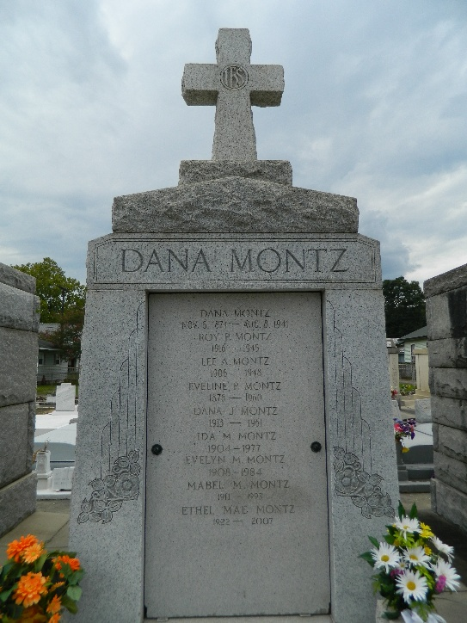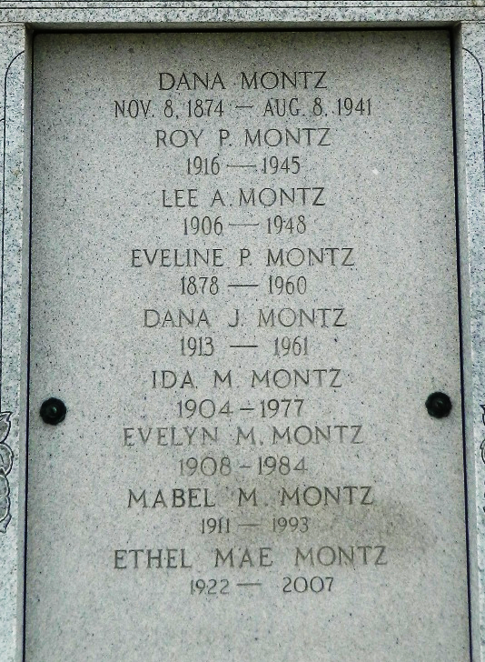

Age 82 years, a native and resident of Reserve, Louisiana.

Daughter of the late Dana A Montz and Eveline Perret Montz. Sister of Ethel Mae Montz and the late Lovincy, Lee, Roy P, Dana J, Ida and Evelyn Montz.

Services were Tuesday 10 Aug 1993 at St Peter Church, Reserve, with interment in St Peter Cemetery.

Unknown source

