Marie Alice (Cambre) Montz
January 19, 1848 – December 5, 1908

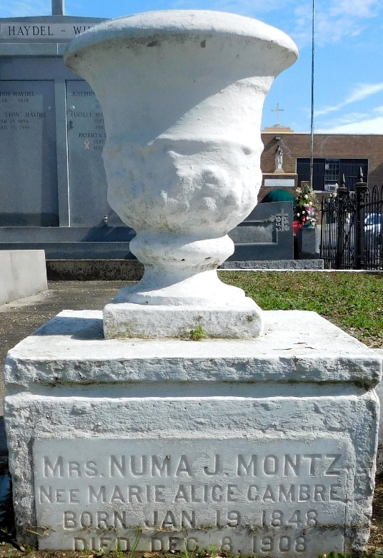
Photo by Mary Agnes Hammett

Mrs. Numa Montz, nee Marie Alice Cambre, died at Laplace, Louisiana, on Saturday, 5 Dec 1908 at 11 o'clock am at age 60 years and 10 months. She was a native of St John the Baptist Parish, Louisiana.

Services were Sunday, 6 Dec 1908 at 10 o'clock in the morning at St Peter Church in Reserve, Louisiana, with interment in St Peter Cemetery.
The Times-Picayune, New Orleans, Louisiana
December 6, 1908

