Marie Celeste Montz
September 26, 1883 – November 20, 1925

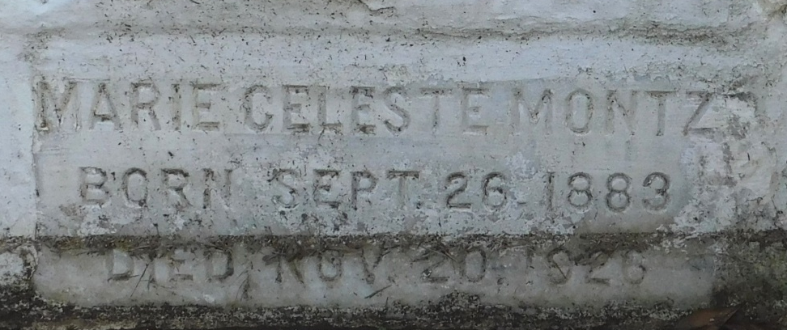
Photo by Mary Agnes Hammett

Marie Montz, daughter of Alice Cambre and Numa Montz, died Saturday evening, 20 Nov 1926.

Services were from the family home in Laplace, Louisiana, at 9 o'clock Monday morning, 22 Nov 1926, with interment in St Peter Cemetery, Reserve, Louisiana.
The Times-Picayune, New Orleans, Louisiana
November 22, 1926

